**Apollo 13**

*A Successful Failure*



Educational Materials for Boy Scouts

*The story of courage, ingenuity, and teamwork*

*that brought three astronauts home from the Moon*

NARRATIVE SLIDE #1

# LAUNCH & MISSION OVERVIEW

*April 11, 1970 | "Houston, we're going to the Moon"*

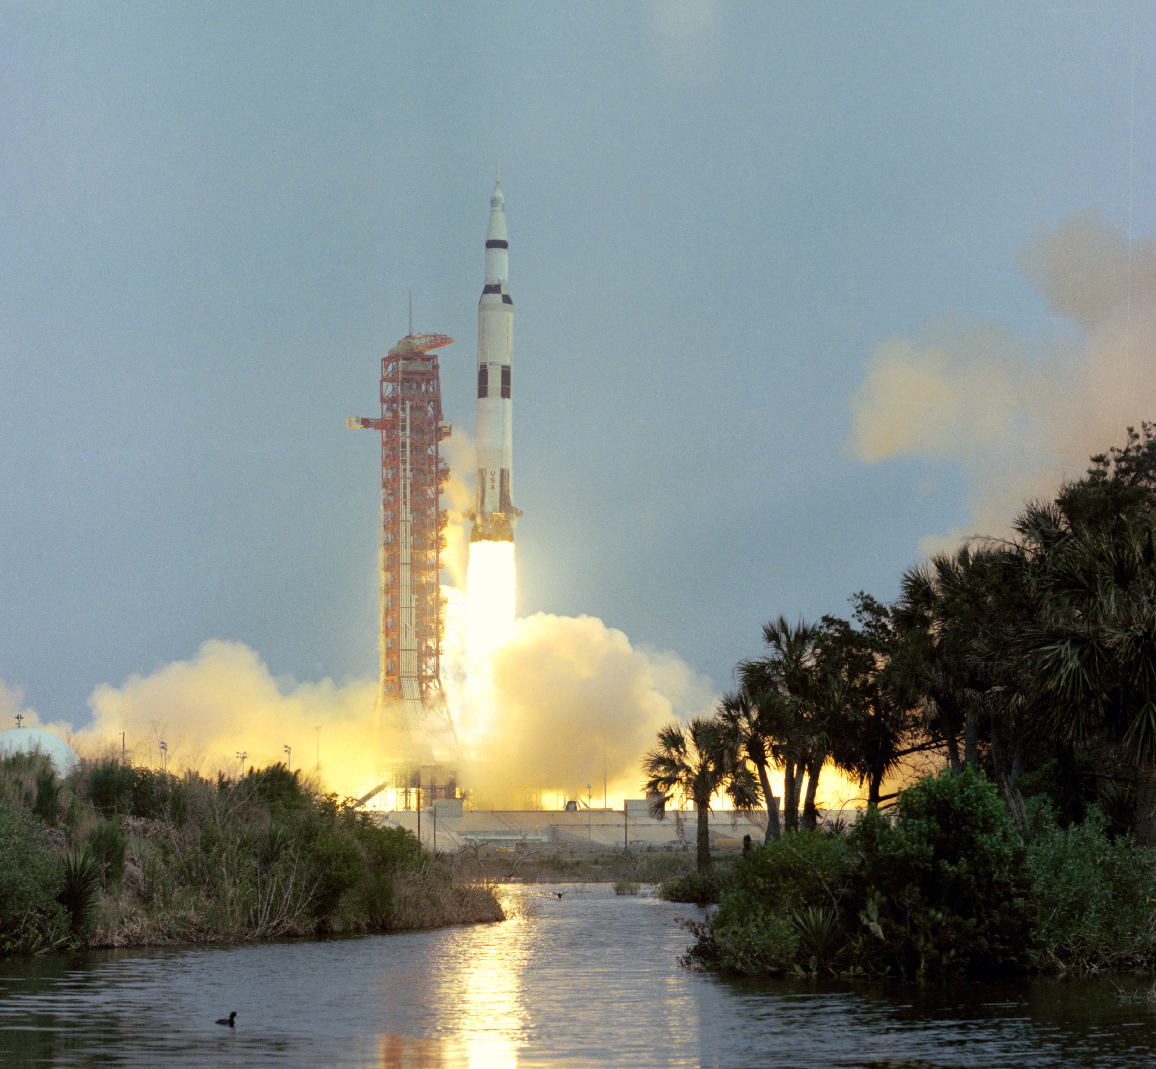

## THE MISSION

Apollo 13

Launched: April 11, 1970, 2:13 PM EST

Destination: Fra Mauro highlands on the Moon

Mission Duration (planned): 10 days

## MEET THE CREW

Commander: Jim Lovell

* Age 42, Navy Captain
* Fourth spaceflight (Gemini 7, 12, Apollo 8)
* Already orbited the Moon on Apollo 8
* Most experienced astronaut flying

Command Module Pilot: Jack Swigert

* Age 38, civilian test pilot
* First spaceflight
* Replaced Ken Mattingly 72 hours before launch (measles exposure)
* Backup crew member called up last minute

Lunar Module Pilot: Fred Haise

* Age 36, Marine Corps, test pilot
* First spaceflight
* Would have walked on Moon at Fra Mauro

## THE SPACECRAFT

Command Module "Odyssey"

* Crew cabin and re-entry capsule
* Only module with heat shield
* ~210 cubic feet living space

Service Module

* Oxygen tanks, fuel cells, main engine (SPS)
* Provides power, oxygen, propulsion
* Jettisoned before re-entry

Lunar Module "Aquarius"

* Moon landing craft (won't be used as intended)
* Designed for 2 people for 2 days
* Would become unlikely lifeboat

## LAUNCH DAY

GET 00:00:00 - Liftoff from Kennedy Space Center

* Saturn V rocket performs flawlessly
* Minor issue: S-II center engine shuts down early (pogo vibrations)
* Other engines compensate—still reach orbit

GET ~00:05:30 - Trans-Lunar Injection (TLI)

* Third stage fires—Apollo 13 heads for the Moon
* Everything nominal—smooth flight ahead
* Or so they thought...

## THE JOURNEY BEGINS

Day 1-2: Routine cruise to Moon

* Systems checks all green
* Crew performs TV broadcast for public
* Trajectory adjusted for Fra Mauro landing site
* NOTE: Spacecraft taken OFF free-return trajectory to aim for landing

Day 3: Everything changes...

## MISSION STATUS

✅ Launch: Success

✅ Trans-Lunar Injection: Success

✅ Course to Moon: On track

⏳ Fra Mauro landing: Still planned

❓ What could possibly go wrong?

NEXT: The Explosion (GET 55:54:53)

INFO SLIDE #1

# MEET THE CREW

*Three Men, One Mission, Impossible Odds*

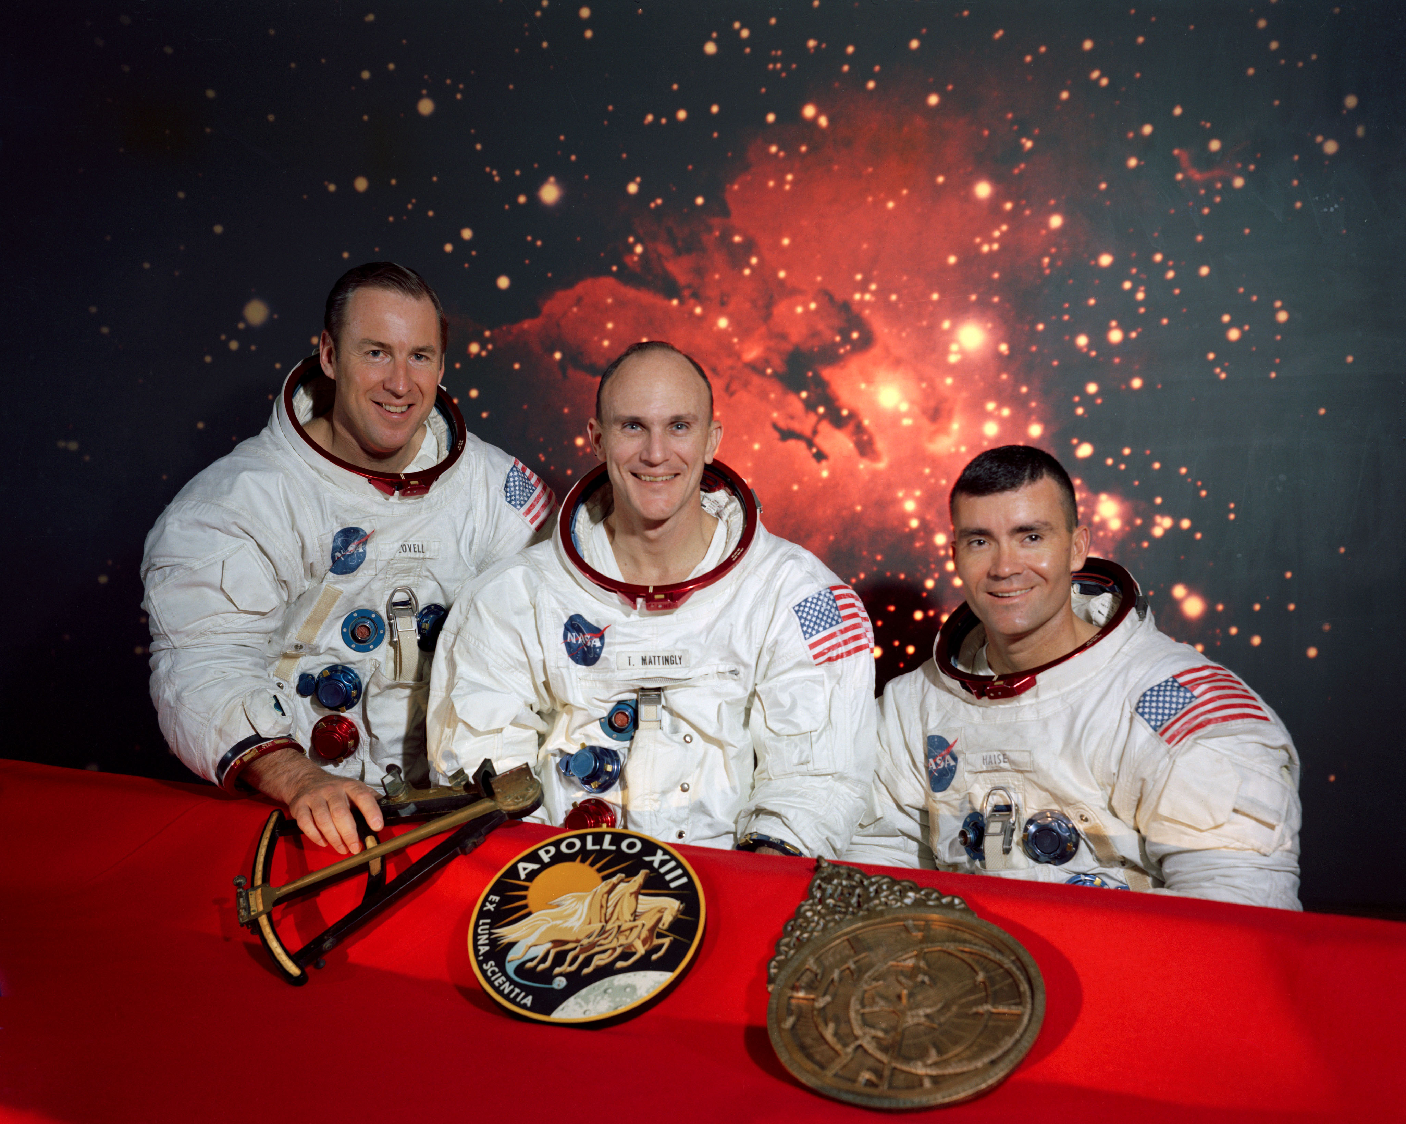

## COMMANDER: JIM LOVELL

Age: 42

Rank: Navy Captain

Experience: Fourth spaceflight

**Previous Missions:**

* Gemini 7 (1965) - 14-day endurance record
* Gemini 12 (1966) - Final Gemini mission
* Apollo 8 (1968) - First humans to orbit Moon

**Apollo 13 Role:**

* Overall mission commander
* Decision-making authority
* Navigation specialist
* Most experienced astronaut flying

**Fun Facts:**

* Holds record for most time in space (before Apollo 13)
* Had already orbited the Moon on Apollo 8
* Was backup commander for Apollo 11
* Calm under pressure - perfect for crisis

**Quote:**

"Houston, we've had a problem."

## COMMAND MODULE PILOT: JACK SWIGERT

Age: 38

Background: Civilian test pilot

Experience: First spaceflight (rookie)

**The Late Addition:**

* Backup crew member
* Replaced Ken Mattingly 72 hours before launch
* Mattingly exposed to measles (never got sick)
* Swigert: "I'm ready to go"

**Apollo 13 Role:**

* Command Module systems expert
* Backup pilot for spacecraft
* Systems troubleshooting
* Never walked on Moon (CM stays in orbit)

**The Moment:**

* Flipped the switch to stir oxygen tanks
* Explosion happened during his action
* Felt guilty but not at fault
* Stayed focused despite stress

**Fun Facts:**

* Bachelor (only unmarried Apollo astronaut)
* Earned law degree while training
* Great sense of humor under pressure

**Quote:**

"Okay, Houston, we've had a problem here."

(First to report the explosion)

## LUNAR MODULE PILOT: FRED HAISE

Age: 36

Background: Marine Corps, test pilot

Experience: First spaceflight (rookie)

**The Dream:**

* Would have been 6th person to walk on Moon
* Trained for Fra Mauro landing
* LM expert - knew every system
* Ended up LIVING in the LM instead

**Apollo 13 Role:**

* Lunar Module systems expert
* Would have piloted landing (never happened)
* Critical for LM-as-lifeboat operations
* Engineering troubleshooting

**The Suffering:**

* Developed kidney/urinary infection
* Fever reached 103°F during mission
* Severe dehydration made it worse
* Pushed through pain to complete mission

**Fun Facts:**

* Flew 19 different types of aircraft
* NASA research pilot before astronaut selection
* Later tested Space Shuttle approach/landing

**Quote:**

"We'll worry about that when we get on the ground."

(On dealing with his kidney infection)

## THE BACKUP CREW

**Would have flown on Apollo 16:**

Commander: John Young

* Veteran astronaut
* Later walked on Moon (Apollo 16)
* Later commanded first Space Shuttle flight

Command Module Pilot: Ken Mattingly

* Pulled from Apollo 13 (measles exposure)
* Flew Apollo 16 as CMP
* Key player in Mission Control during Apollo 13
* Helped devise power-up procedures

Lunar Module Pilot: Charles Duke

* Later walked on Moon (Apollo 16)
* CapCom during Apollo 11 landing

## THE GROUND TEAM

**Mission Control - Houston:**

Flight Director: Gene Kranz

* White vest (his lucky vest)
* "Failure is not an option" spirit
* Led problem-solving efforts
* Calm leadership under crisis

**CapCom (Capsule Communicator):**

* Jack Lousma (during explosion)
* Joe Kerwin (during re-entry)
* Only voice crew hears from Earth
* Former astronauts who speak the language

EECOM (Electrical, Environmental, Consumables):

* Sy Liebergot (on duty during explosion)
* "We may have had an instrumentation problem"
* Quickly realized it was real

Hundreds of engineers working around the clock

## FAMILY SUPPORT

**On Earth, Waiting:**

Marilyn Lovell (Jim's wife)

* Four children at home
* Stayed strong for media
* Trusted NASA to bring him home

**Fred Haise's family:**

* Wife Mary
* Four children

**Jack Swigert's family:**

* Mother and siblings (unmarried)
* Worried but confident

**The Families' Vigil:**

* 24/7 media at their doors
* Phone calls from Mission Control
* Watching every TV update
* Praying for safe return

## CREW DYNAMICS

**The Team:**

* One veteran commander (Lovell)
* Two rookies (Swigert, Haise)
* Last-minute crew change (Swigert)
* Minimal time to train together

**Under Crisis:**

✅ Trusted each other completely

✅ No blame, only problem-solving

✅ Each focused on their expertise

✅ Worked as seamless team

✅ Calm under impossible pressure

**The Bond:**

* Formed under fire
* Life-and-death dependence
* Lifelong friendship
* Forever linked by survival

## POST-MISSION

**What Happened After:**

**Jim Lovell:**

* Retired from NASA (1973)
* Never flew in space again
* Business career
* Co-wrote book "Lost Moon" (basis for movie "Apollo 13")

**Jack Swigert:**

* Left NASA (1977)
* Elected to U.S. Congress (1982)
* Died of cancer before taking office (age 51)

**Fred Haise:**

* Continued at NASA
* Space Shuttle approach and landing tests
* Retired 1979
* Aerospace industry career

## THE LEGACY

Three men.

One damaged spacecraft.

200,000 miles from home.

Four days of crisis.

Zero margin for error.

They worked the problem.

They trusted their team.

They never gave up.

And they came home.

"Apollo 13: A Successful Failure"

NARRATIVE SLIDE #2

# THE EXPLOSION

*April 13, 1970 | "Houston, we've had a problem"*

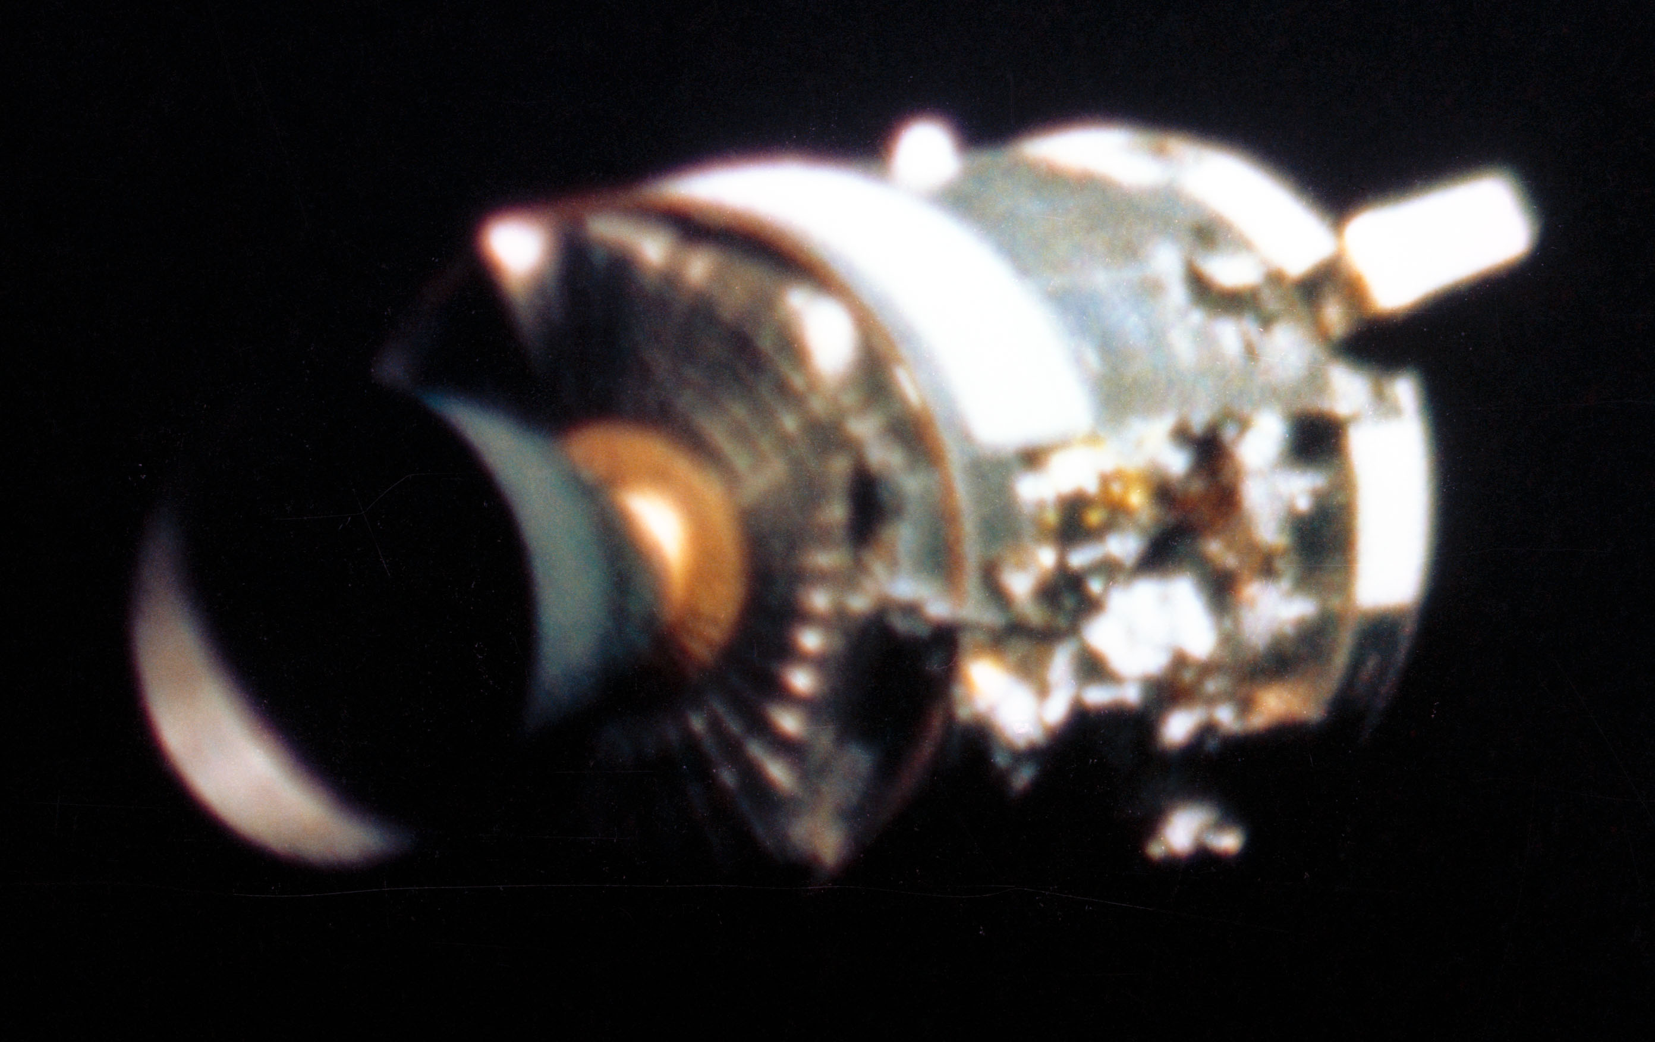

## THE SETUP

Day 3 - April 13, 1970

GET 55:54:53 (~9:08 PM Houston time)

Distance from Earth: ~200,000 miles

Speed: ~24,000 mph (traveling away from Earth)

Status: All systems normal, routine evening

## THE ROUTINE REQUEST

**Mission Control to Jack Swigert:**

"We'd like you to stir up your cryo tanks"

**Standard procedure:**

* Stir oxygen tanks to get accurate readings
* Oxygen stored as supercold liquid
* Fans stir tanks to prevent stratification
* Done dozens of times on previous missions
* Should take 10 seconds...

## 55:54:53 - BANG

Swigert flips the switch...

**LOUD BANG**

Spacecraft shakes violently

Master alarm sounds

Warning lights everywhere

Crew feels the ship lurch

Jack Swigert: "Okay, Houston, we've had a problem here"

Houston: "Say again please"

Jim Lovell: "Houston, we've had a problem"

## WHAT THEY SAW

**Through the window:**

* "Sparklies" - glittering debris field
* Venting gas creating cloud around spacecraft
* Something is catastrophically wrong
* Oxygen pouring into space

**On the instruments:**

* Oxygen tank 2 pressure: ZERO
* Oxygen tank 1 pressure: FALLING
* Two fuel cells offline
* Main bus B voltage dropping
* Warning lights cascading

Lovell: "We are venting something out into space"

## THE DAMAGE (Unknown at the time)

**What actually happened:**

* Oxygen tank #2 exploded in Service Module
* Entire 13-foot panel blown off spacecraft
* Damaged oxygen tank #1 (now leaking)
* Fuel cells failing (need oxygen to generate power)
* Service module crippled
* Main engine (SPS) unsafe to use

Crew won't see the damage until SM jettison (GET 138:02)

## THE CRISIS UNFOLDS

**Immediate problems:**

* Losing oxygen rapidly (need it to breathe)
* Losing power (fuel cells dying)
* Losing main engine (can't thrust home directly)
* 200,000 miles from Earth
* Traveling AWAY from home at 24,000 mph
* Command Module will be dead in hours

**Mission Control realizes:**

* Moon landing: IMPOSSIBLE
* Normal return: IMPOSSIBLE
* Crew survival: UNCERTAIN

**Gene Kranz (Flight Director):**

"Okay, let's everybody keep cool. Let's solve the problem, but let's not make it any worse by guessing."

## WHAT'S AT STAKE

**The math is brutal:**

* 3 astronauts
* 200,000 miles from Earth
* Crippled spacecraft
* Limited oxygen, power, water
* 4+ days to get home
* Margin for error: ZERO

This is now a survival mission.

NEXT DECISION: Turn Around or Free-Return?

INFO SLIDE #2

# WHAT CAUSED THE EXPLOSION?

*Oxygen Tank #2 — A Chain of Small Mistakes*

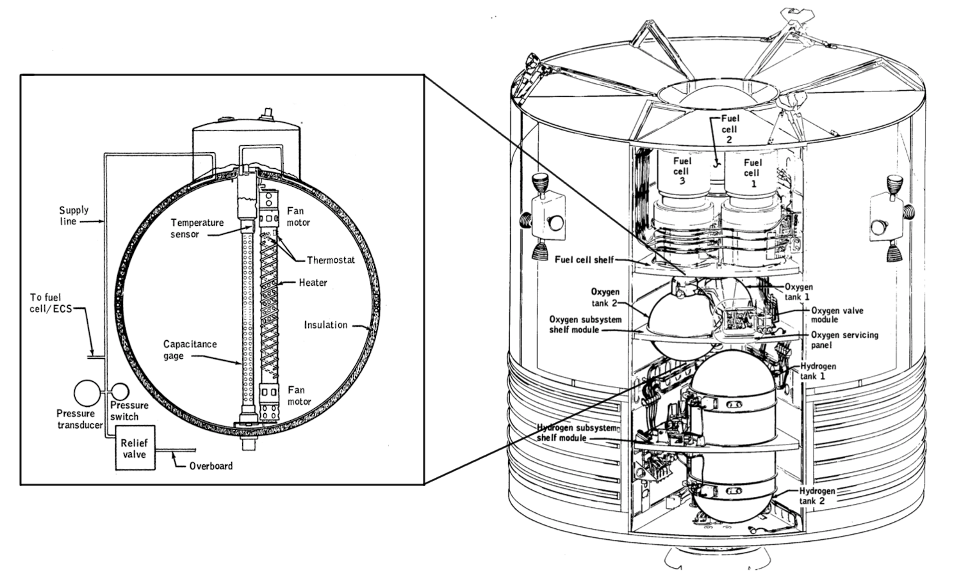

## THE SIMPLE ANSWER

Oxygen tank #2 in the Service Module exploded at GET 55:54:53

But WHY did it explode?

The real answer: Three mistakes over two years.

## MISTAKE #1: THE DROP (1968)

**During Manufacturing:**

**What Happened:**

* Oxygen Tank #2 was dropped about 2 inches
* Happened during removal before it was installed in Apollo 13's Service Module
* This likely damaged its fill/drain line inside
* Workers inspected the outside: looked fine
* Internal damage NOT detected

**The Problem:**

* Fill/drain system probably bent or cracked
* Would cause trouble later during testing
* But no one knew yet

Result: Hidden damage went unnoticed

## MISTAKE #2: THE DESIGN CHANGE (1965)

**The Voltage Mismatch:**

**Original Design:**

* All spacecraft systems ran on 28 volts
* Thermostatic switches designed for 28 volts
* Everything matched and worked safely

**NASA's Change:**

* Upgraded ground test equipment to 65 volts
* More powerful, better for testing
* MOST components upgraded to handle 65 volts
* BUT: Tiny thermostat switches NOT upgraded (still rated for 28V)

**Why It Mattered:**

* Higher voltage = more heat in switches
* Switches designed for 28V now carrying 65V
* If they got too hot, they could weld shut
* Then they couldn't turn off the heaters!

Result: Safety system compromised

## MISTAKE #3: THE TESTING INCIDENT (March 1970)

**Pre-Launch Ground Test (CDDT):**

**The Test:**

* March 1970 - About one month before launch
* Fill oxygen tank for countdown test
* Time to drain tank after test is done
* Normal drain valve wouldn't work (damaged from drop?)

**The "Solution":**

* Workers couldn't drain tank normally
* So they used heaters and fans to boil off the oxygen
* Ran ground power at ~65 volts
* Left heaters running for about 8 HOURS to empty tank

**What Actually Happened:**

* Temperature inside tank reached ~1,000°F (540°C!)
* That's hot enough to melt aluminum
* But temperature gauge only read up to 85°F
* Workers saw 85°F and thought everything was fine
* Real temperature was 12× hotter than gauge could show!

**The Damage:**

* Thermostat switches welded shut from extreme heat
* Teflon wire insulation melted and burned off
* Bare electrical wires exposed inside tank
* Pure oxygen environment (extremely flammable)
* Bomb waiting to explode

**Warning Signs Missed:**

* Unusual readings during test
* But technicians didn't understand what they meant
* Tank passed pressure tests (pressure was fine)
* Exterior looked normal
* Cleared for flight

Result: Damaged tank loaded onto Apollo 13

## THE EXPLOSION (April 13, 1970)

GET 55:54:53 — Routine Request, Catastrophic Result:

**Mission Control's Request:**

"We'd like you to stir up your cryo tanks."

**Standard Procedure:**

* Stir oxygen fans to get accurate readings
* Done many times on every mission
* Should take 10 seconds
* Completely routine

**What Happened:**

1. Jack Swigert flips switch to activate Tank #2 fans

2. Electricity flows through DAMAGED WIRING

3. Bare wires spark inside tank

4. Spark ignites in pure oxygen environment

5. Fire spreads instantly (oxygen makes everything burn)

6. Pressure builds rapidly

7. EXPLOSION rips through tank

8. Blast blows off entire 13-foot panel from Service Module

9. Damages Tank #1 (now leaking oxygen)

10. Fuel cells fail (need oxygen to make power)

11. Spacecraft crippled 200,000 miles from Earth

**The Physics:**

* Pure oxygen makes fire burn 10× hotter and faster
* 900+ psi pressure released like bomb
* Explosion visible through windows ("sparklies")
* Oxygen venting into space like jet
* Spacecraft tumbling from blast

## THE TIMELINE

**How Three Mistakes Combined:**

1968: Tank dropped → Fill line damaged

1965: Voltage upgrade → Switches can't handle heat

March 1970: 8-hour heater test → Wiring burned

April 13, 1970: Routine stir → EXPLOSION

Any ONE mistake prevented = no explosion

All three mistakes together = disaster

## THE DAMAGE

**What the Explosion Destroyed:**

**Service Module:**

❌ Oxygen Tank #2: Completely destroyed (exploded)

❌ Oxygen Tank #1: Damaged, leaking rapidly

❌ Fuel Cell 1: Offline (no oxygen to make power)

❌ Fuel Cell 2: Offline (no oxygen to make power)

❌ Fuel Cell 3: Offline (no oxygen to make power)

❌ Side panel: Entire 13-foot section blown off

❌ High-gain antenna: Damaged

⚠️ Main engine (SPS): Unknown damage, unsafe to use

**Command Module:**

⚠️ Running on batteries only (fuel cells dead)

⚠️ Oxygen leaking from damaged Service Module

⚠️ Must power down to save batteries

⚠️ Temperature will drop to freezing

**Lunar Module "Aquarius":**

✅ Completely undamaged (separate from explosion)

✅ Own oxygen supply (independent tanks)

✅ Own power (separate batteries)

✅ Becomes the lifeboat that saves three lives

## WHY THIS MATTERS

**Lessons About Safety:**

**Small Problems Can Become Big:**

* 2-inch drop seemed minor
* Voltage mismatch seemed unimportant
* 8-hour test seemed normal
* Together: nearly killed three men

**Check Everything Carefully:**

* Inspect inside, not just outside
* Match voltage ratings exactly
* Watch for unusual readings
* Don't assume "looks fine" means "is fine"

**Multiple Backups Save Lives:**

* Tank #1 damaged but LM had oxygen
* Fuel cells failed but LM had batteries
* Main engine unsafe but LM engine worked
* Redundancy meant survival

## WHAT NASA CHANGED

**After Apollo 13:**

**Oxygen Tank Redesign:**

✅ Added third oxygen tank (more redundancy)

✅ Put third tank in different location (separate from #1 and #2)

✅ Upgraded all thermostatic switches to proper voltage

✅ Better wire insulation (won't burn in oxygen)

✅ Redesigned heaters (safer, can't overheat)

✅ Temperature gauges read full range (no hidden overheating)

**Testing Improvements:**

✅ Never use heaters to drain tanks (new drain procedures)

✅ X-ray inspect all pressure vessels

✅ Document every unusual reading (investigate fully)

✅ Double-check voltage ratings on ALL components

✅ Temperature monitoring during all tests

**Inspection Rules:**

✅ Report all drops, no matter how small

✅ Full internal inspection after any damage

✅ Don't launch if anything seems unusual

✅ "When in doubt, check it out"

**Every Apollo Mission After:**

* Used redesigned oxygen tanks
* Safer testing procedures
* More careful inspections
* Zero oxygen tank failures

## DID YOU KNOW?

**Strange Facts:**

* The explosion happened at 13:13 military time (Houston)
* Mission number: Apollo 13
* Launch date: 4/11/70 (add digits: 4+1+1 = 6, plus 7+0 = 7... both unlucky?)
* Superstitious? Maybe just coincidence.
* The actual cause wasn't discovered until months after landing
* Investigation took 3,000+ hours of testing
* Engineers recreated the damage in lab
* Found melted Teflon inside test tanks
* Tank #2 was originally built for Apollo 10
* Moved to Apollo 13 after modifications
* If it had stayed on Apollo 10, might have exploded there instead
* Apollo 10 crew: Very lucky

## THE LESSON

Not Bad Luck. Bad Wiring.

**Three mistakes:**

1. DROP (damaged fill line)

2. VOLTAGE (switches couldn't handle it)

3. TEST (8 hours of hidden overheating)

One explosion.

Three men survived.

Countless lessons learned.

Don't blame superstition.

Blame damage no one caught.

**And remember:**

Small mistakes add up.

Check everything twice.

Safety always matters.

💥 Three Mistakes → One Explosion → Zero Deaths

**CAUSE IDENTIFIED. CREW SAVED. NEVER REPEATED.**

DECISION POINT #1

# TURN AROUND OR FREE-RETURN?

*GET ~61:29:42 | Post-Explosion Crisis*

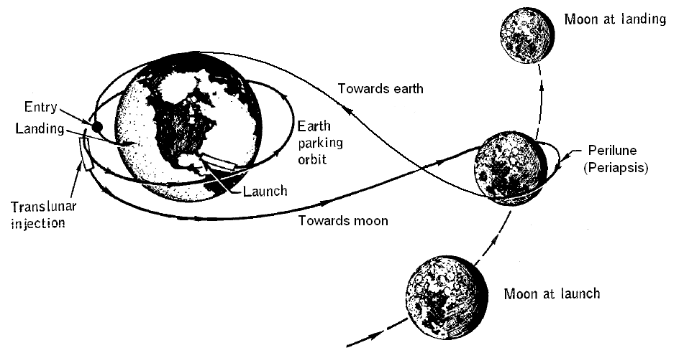

## THE SITUATION

* Oxygen tank explosion at GET 55:54:53 (~200,000 miles from Earth)
* Currently traveling ~24,000 mph away from Earth
* Service module damaged, command module rocket uncertain
* Fuel cells offline, running on backup batteries
* Must decide route home: direct reversal or loop around Moon

## OPTION 1: TURN AROUND

Subtitle: Blast retrograde to stop and reverse direction

**PROS:**

* Fastest route home (shortest total time)
* Direct path back to Earth
* Familiar trajectory calculations
* No need to wait for Moon flyby

**CONS:**

* Requires massive fuel burn
* Risks explosion of damaged systems
* Burns through all LM descent fuel
* May damage weakened spacecraft structure
* Untested with damaged systems

## OPTION 2: FREE-RETURN TRAJECTORY

Subtitle: Use Moon's gravity to slingshot back

**PROS:**

* Safer for damaged systems
* Uses significantly less fuel
* Proven orbital mechanics (tested on Apollo 8, 10)
* Uses undamaged LM descent engine
* Conserves resources for course corrections

**CONS:**

* Takes much longer (must loop around Moon first)
* Crew waits 4+ days in damaged spacecraft
* More time for systems to fail
* Psychological stress of waiting
* More consumables needed (oxygen, water, power)

## DECISION PROMPT

**🤔 WHAT SHOULD THE CREW DO?**

## HISTORICAL DECISION

NASA chose FREE-RETURN TRAJECTORY

* GET 61:29:42 - DPS burn (~31 seconds using LM descent engine)
* Put spacecraft back on free-return path that loops behind Moon
* Safer approach that doesn't stress damaged systems
* Used undamaged LM engine instead of risky CSM engine
* Required patience but conserved critical resources

DECISION POINT #2

# FREEZE OR SQUEEZE?

*GET ~56:00:00 | Command Module Failing*

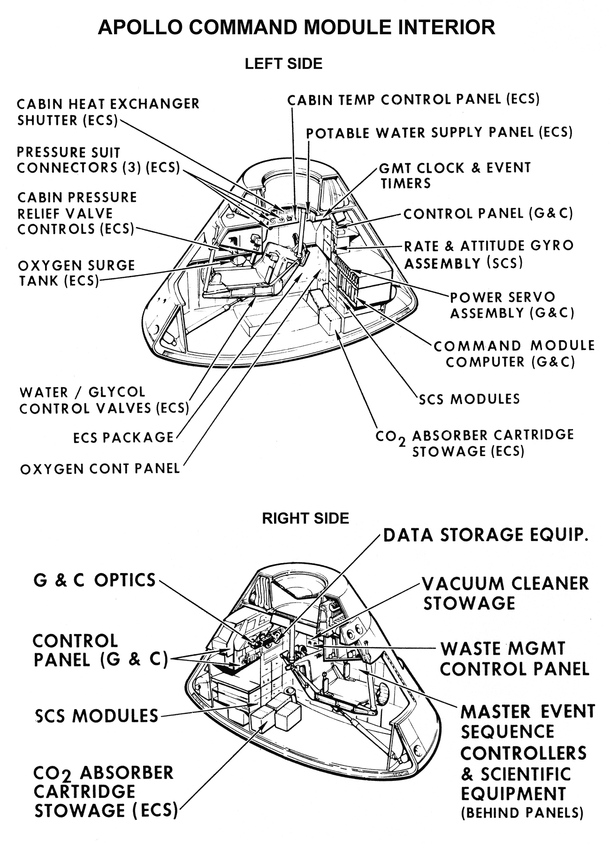

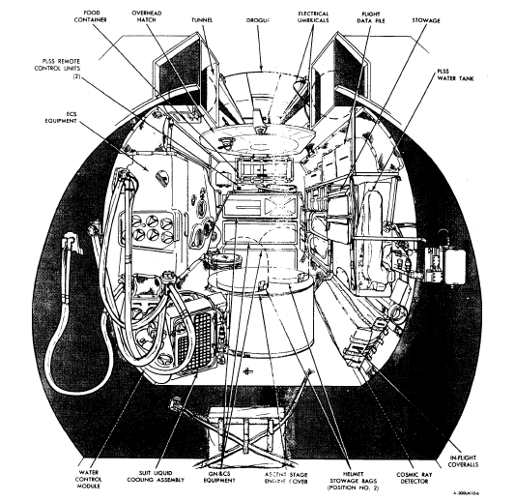

## THE SITUATION

* Command Module "Odyssey" losing power and oxygen rapidly
* Cabin heat comes from electrical systems—must shut down to save batteries
* Temperature in CM will drop to freezing (38°F)
* Lunar Module "Aquarius" designed for 2 people for 2 days
* Need life support for 3 people for 4+ days

## OPTION 1: FREEZE

Subtitle: Stay in Command Module

**PROS:**

* More spacious (~210 cubic feet)
* Familiar systems and controls
* Only module with heat shield for re-entry

**CONS:**

* No power = no heat, will freeze
* Limited oxygen remaining
* No life support systems active
* Crew will not survive 4 days

## OPTION 2: SQUEEZE

Subtitle: Move to Lunar Module

**PROS:**

* Power available from LM batteries
* Life support systems functional
* Oxygen reserves sufficient
* Can survive the journey home

**CONS:**

* Extremely cramped (~160 cubic feet)
* Designed for 2, now holding 3
* Moving disturbs others—no sleep
* Still cold (38°F), condensation on walls
* Power & water very tight

## DECISION PROMPT

**🤔 WHAT SHOULD THE CREW DO?**

## HISTORICAL DECISION

NASA chose SQUEEZE into Lunar Module "Aquarius"

* GET ~56:00:00 - Power down Command Module
* All three crew moved to LM as lifeboat
* So crowded that moving arms/legs disturbed others
* Sleep deprivation became major issue
* LM kept them alive for the entire journey home

INFO SLIDE #3

# SPACECRAFT CONFIGURATION

*The Three-Module System That Saved Lives*

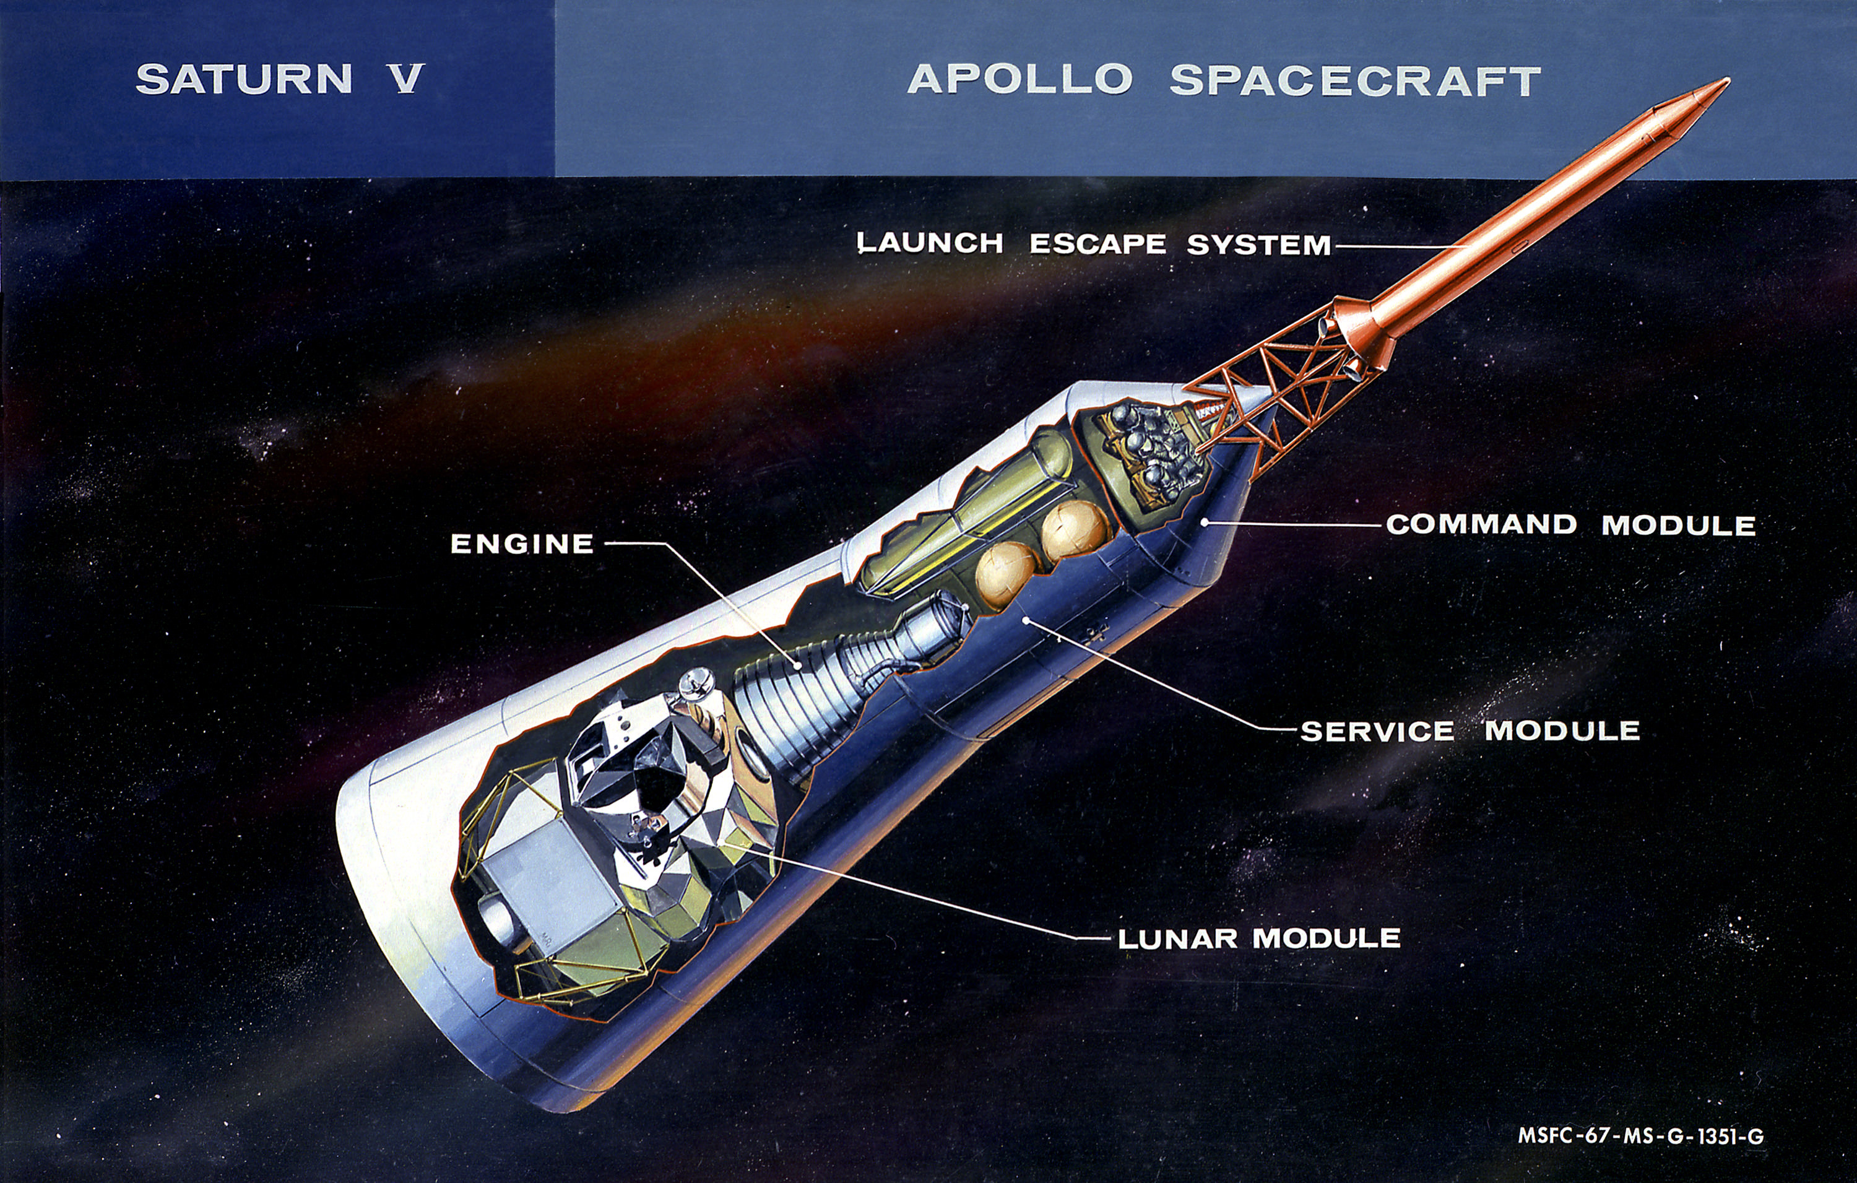

## THE APOLLO SPACECRAFT

**Three Modules, Three Purposes:**

Total Length: ~80 feet (nose to engine)

Total Weight: ~100,000 lbs at launch (varies by mission)

Power: Fuel cells + batteries

Life Support: Oxygen + water systems

## COMMAND MODULE (CM) "ODYSSEY"

The Crew Cabin and Re-Entry Capsule

**Dimensions:**

* Height: 10.6 feet
* Diameter: 12.8 feet (at base)
* Volume: ~210 cubic feet (habitable)
* Weight: ~12,000 lbs
* Shape: Cone (for aerodynamics during re-entry)

**Crew Positions:**

* Commander (left couch)
* Command Module Pilot (center couch)
* Lunar Module Pilot (right couch)
* Three astronauts in spacesuits

**What It Provides:**

✅ Crew living quarters during flight

✅ ONLY module with heat shield for re-entry

✅ Navigation and guidance systems

✅ Communications equipment

✅ Parachutes for landing

✅ Re-entry batteries (backup power)

**Critical Features:**

* Heat shield: Ablative material burns away during re-entry
* Parachutes: Three 83-foot diameter chutes
* Windows: Five for visibility
* Docking tunnel: Connects to LM through hatch

**Apollo 13 Status:**

* Powered down to conserve batteries (GET ~56:00:00)
* Temperature dropped to 38°F
* Condensation and ice on walls
* Essential for re-entry only
* Crew abandoned it for LM lifeboat

## SERVICE MODULE (SM)

The Power and Propulsion Workhorse

**Dimensions:**

* Length: 24.6 feet
* Diameter: 12.8 feet
* Weight: ~54,000 lbs (fully loaded)
* Shape: Cylinder

**What It Contains:**

**🔋 Fuel Cells (3 total):**

* Generate electricity from oxygen + hydrogen
* Produce drinking water as byproduct
* Primary power source for mission

**🌬️ Oxygen Tanks (2):**

* Cryogenic liquid oxygen (-297°F)
* Supply fuel cells and breathing air
* Tank #2 exploded on Apollo 13

**🚀 Service Propulsion System (SPS):**

* Main rocket engine
* 20,500 lbs thrust
* Used for major course corrections
* Critical for lunar orbit insertion/departure
* Apollo 13: NEVER USED (too risky after explosion)

**📡 High-Gain Antenna:**

* Communications with Earth
* Damaged in explosion

**⚡ Electrical Systems:**

* Batteries, wiring, distribution
* Radiators for cooling

**Sector Layout:**

* Divided into 6 pie-shaped sectors
* Sector 4: Where oxygen tank #2 exploded
* Entire panel (13 feet) blown off

**Apollo 13 Damage:**

❌ Oxygen tank #2: Destroyed

❌ Oxygen tank #1: Leaking

❌ All fuel cells: Offline

❌ Panel blown off: Massive structural damage

❌ Main engine: Unsafe to use

## LUNAR MODULE (LM) "AQUARIUS"

The Moon Lander That Became a Lifeboat

**Dimensions:**

* Height: 22.9 feet (legs extended)
* Width: 31 feet (diagonal across legs)
* Crew Area: ~160 cubic feet (standing room only)
* Weight: ~33,000 lbs (fully loaded)

**Two Stages:**

**1. Descent Stage (bottom):**

• Landing legs and engine

• Descent Propulsion System (DPS)

• Fuel tanks

• Equipment storage

• Stays on Moon after landing

**2. Ascent Stage (top):**

• Crew cabin (cramped!)

• Ascent engine

• Life support

• Returns to orbit

**Crew Cabin Layout:**

* NO SEATS - designed for standing only
* Two triangular windows (for landing visibility)
* Controls and displays on instrument panel
* Designed for 2 astronauts for 45 hours (Moon landing mission)

**What It Provides:**

✅ Independent oxygen supply

✅ Battery power (separate from CM/SM)

✅ Descent engine for course corrections

✅ Life support systems

✅ Water cooling for electronics

✅ Communications (backup)

**LM Systems:**

* Oxygen: Stored for 2 people for 2 days
* Power: Batteries for 45-hour lunar mission
* Water: For cooling and drinking
* CO2 Scrubbers: ROUND lithium hydroxide canisters

**Apollo 13 Lifeboat Role:**

✅ Supported 3 people for 4+ days (beyond design!)

✅ Provided all oxygen and power

✅ Descent engine made all course corrections

✅ Kept crew alive in freezing conditions

✅ Cramped but functional

**The Squeeze:**

* Designed: 2 people, 45 hours
* Reality: 3 people, 87+ hours
* Temperature: 38°F (freezing)
* Condensation everywhere
* No sleep possible
* But it worked!

## HOW THEY CONNECT

**The Docking System:**

**Launch Configuration:**

1. Command Module (top/nose)

2. Service Module (middle - attached to CM)

3. Lunar Module (stored in adapter - below SM)

4. Saturn V rocket (bottom - propulsion)

**After Launch:**

1. CM/SM separate from Saturn V

2. CM/SM turn around (180° rotation)

3. CM docks with LM nose-to-nose

4. LM extracted from adapter

5. Combined spacecraft flies to Moon

**Docking Tunnel:**

* Connects CM to LM
* 32 inches diameter
* Crew crawls through in zero gravity
* Sealed with hatch on each end

**Apollo 13 Configuration:**

* CM "Odyssey" + SM (damaged) + LM "Aquarius"
* All three modules connected
* Crew used tunnel to move between CM and LM
* LM became primary habitat
* CM powered down but still attached
* SM provided structural support (until jettison)

## JETTISON SEQUENCE (RE-ENTRY)

Step 1 - Service Module Jettison (GET 138:02):

* SM separated from CM
* Drifts away into space
* First view of massive damage
* CM now exposed

Step 2 - Lunar Module Jettison (GET 141:30):

* Tunnel sealed
* LM separated from CM
* "Farewell, Aquarius, and we thank you"
* CM alone for re-entry

**Step 3 - Re-Entry (GET 142:40:46):**

* CM only module with heat shield
* Parachutes deploy from CM
* CM lands in ocean
* SM and LM burn up in atmosphere (eventually)

## SYSTEMS COMPARISON

| System | CM | SM | LM |

|---------------|--------------|--------------|--------------|

| Crew Capacity | 3 seated | 0 (unmanned) | 2 standing |

| Volume | ~210 cu ft | N/A | ~160 cu ft |

| Power | Batteries | Fuel cells | Batteries |

| Main Engine | Small RCS | SPS (big!) | DPS + APS |

| Life Support | Shared w/SM | Provides O2 | Independent |

| Re-entry | YES ✅ | NO (burns) | NO (burns) |

## WHY THREE MODULES?

**Specialization:**

* CM: Optimized for re-entry (heat shield, aerodynamics)
* SM: Power and propulsion workhorse (fuel cells, main engine)
* LM: Moon landing specialist (lightweight, landing legs)

**Weight Savings:**

* Don't carry landing legs to Earth
* Don't carry heavy SM through atmosphere
* Shed weight at each stage

**Redundancy:**

* LM has independent systems (backup!)
* Separate power sources
* Multiple oxygen supplies
* This redundancy saved Apollo 13

## THE LESSON

Three modules, three purposes.

One explosion, one lifeboat.

The LM wasn't supposed to save lives in space.

It was supposed to land on the Moon.

But when Odyssey failed, Aquarius stepped up.

A spacecraft designed for 2 for 2 days

Kept 3 men alive for 4+ days.

Engineering redundancy saved three lives.

**🚀 CM + SM + LM = HOME 🏠**

NARRATIVE SLIDE #3

# LIFEBOAT & MOON FLYBY

*April 13-14, 1970 | Aquarius Becomes Home*

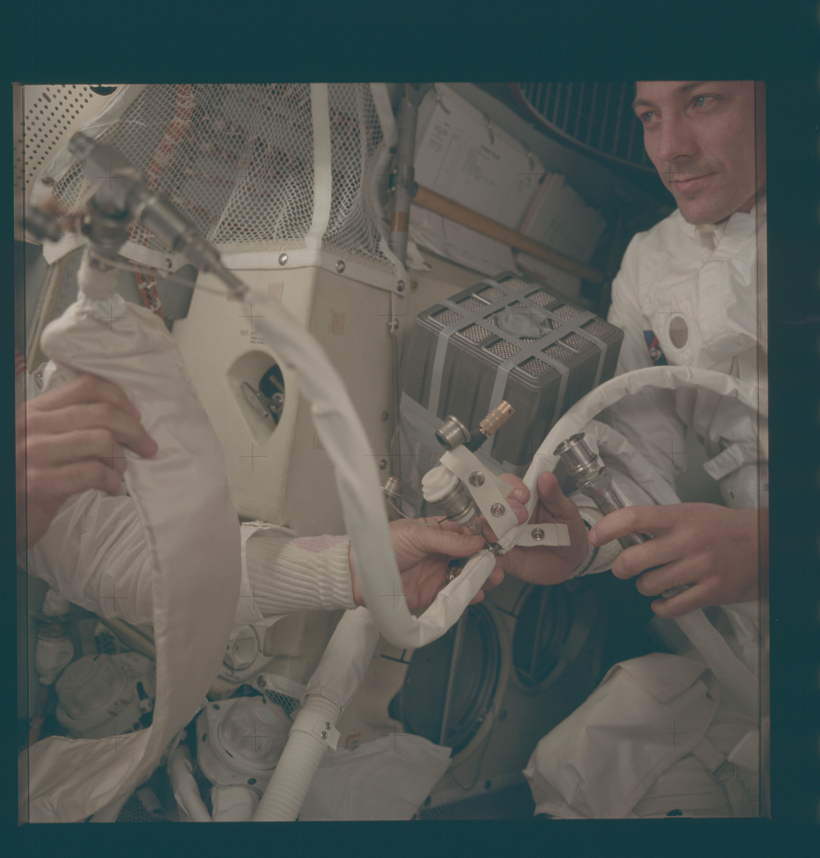

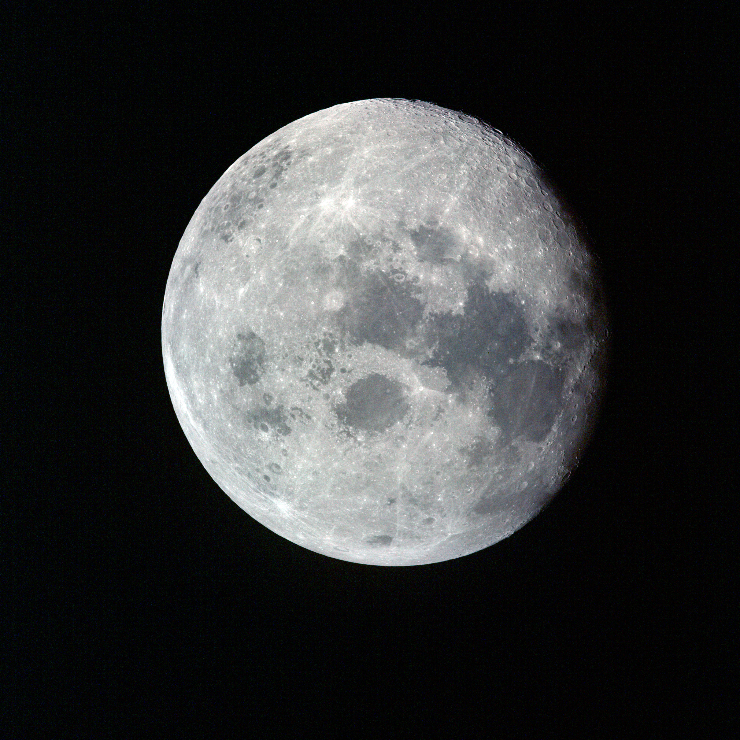

## AFTER THE EXPLOSION

GET ~56:00:00 - The Decision

* Command Module "Odyssey" dying—oxygen nearly gone
* Must power down CM to save batteries for re-entry
* Only option: Lunar Module "Aquarius" as lifeboat
* Problem: LM designed for 2 people for 2 days
* Reality: Must support 3 people for 4+ days

## MOVING TO THE LM

Crew squeezes into "Aquarius"

* Cramped: ~160 cubic feet (like a walk-in closet)
* Designed for standing room, not living quarters
* Three grown men in space suits
* Moving one arm disturbs the other two
* No privacy, no comfort, no sleep

Lovell: "Aquarius, this is Houston. You are GO for undocking."

But they're NOT undocking—they're living in it!

## THE LIFEBOAT

**What Aquarius provides:**

✅ Oxygen reserves (enough for 3... barely)

✅ Battery power (conserve every amp)

✅ Descent engine (for course corrections)

✅ Life support systems (running overtime)

**What it doesn't provide:**

❌ Warmth (temperature drops to 38°F)

❌ Space (extremely cramped)

❌ Comfort (condensation on walls, no sleep)

❌ Certainty (designed for 2 for 2, not 3 for 4)

## SWINGING AROUND THE MOON

GET 61:29:42 - Free-Return Trajectory Burn

* DPS burn (~31 seconds) using LM descent engine
* Put spacecraft back on free-return path
* Will loop behind Moon and head home
* Safer than trying to turn around
* Must wait... but they'll get home

Day 4 - April 14, 1970

Closest Approach to Moon: ~137 nautical miles (~158 miles / ~254 km)

**Through the LM window:**

* Lunar surface rushing below
* Pericynthion (closest point to Moon)
* Should have been landing at Fra Mauro right now
* Instead, just passing by for survival

**Communication Blackout:**

* Spacecraft passes behind Moon
* No radio contact with Earth
* Minutes of silence
* Families hold their breath
* Signal returns—they're alive!

## THE PC+2 BURN

GET 79:27:40 - Speed Up Burn

* Major burn 2 hours after pericynthion
* LM descent engine fires for 4½-5 minutes
* Adds ~900 ft/s velocity
* Shortens trip by ~9-10 hours
* Targets Pacific recovery zone near USS Iwo Jima

**Crew hears the engine:**

* Longest burn yet in damaged spacecraft
* Engine performs flawlessly
* Trajectory set for Pacific Ocean
* Now it's a race against time

## SURVIVAL CONDITIONS

Temperature: 38-50°F (freezing)

* Water condensation on every surface
* Ice forming on equipment
* Crew shivering constantly
* Can see their breath

Water Rations: 6 oz per person per day

* Normal: 64 oz (8 cups)
* Now: Less than 1 cup total
* Severe dehydration setting in
* Haise developing kidney infection

**Power Conservation:**

* Minimal heaters (too cold to sleep)
* Minimal lights (stumbling in dark)
* Minimal communications (families terrified)
* Every amp-hour counts for re-entry

**Sleep Deprivation:**

* Impossible to sleep in cramped, freezing LM
* Constant stress and worry
* Moving disturbs others
* Exhaustion building

## THE LONG WAIT BEGINS

Current position: Behind Moon, heading home

Time to Earth: ~3.5 days

Status: Alive but suffering

**Challenges ahead:**

* CO2 levels rising
* Water running out
* Batteries draining
* Temperature dropping
* Crew weakening

But Aquarius is keeping them alive.

NEXT: The Long Cold Journey Home

DECISION POINT #3

# STARS OR SUN/EARTH NAVIGATION?

*GET ~79:27:38 | Lost in Space*

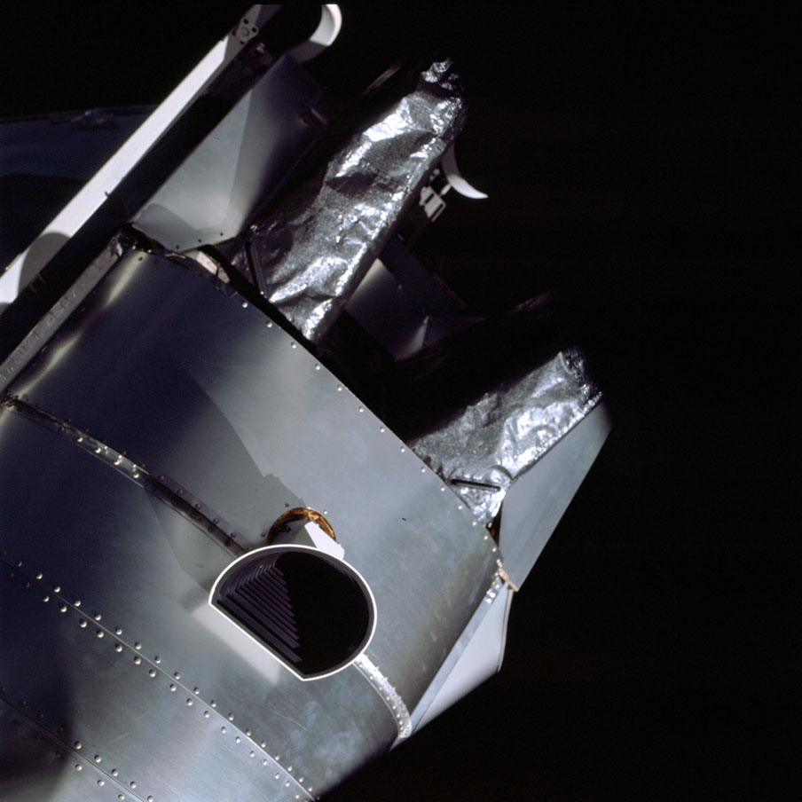



## THE SITUATION

* Need to align spacecraft navigation platform for accurate course corrections
* Normal method: sight on known stars using alignment telescope (AOT)
* Problem: Explosion created debris field—"sparklies" everywhere
* Through telescope, debris looks identical to stars
* Impossible to determine which points of light are real stars
* Without proper alignment, can't aim precisely for Earth

## OPTION 1: STAR SIGHTING

Subtitle: Use alignment telescope to sight on stars

**PROS:**

* Most accurate navigation method available
* Standard Apollo procedure (proven technique)
* Provides precise platform orientation
* Computer can calculate exact trajectory

**CONS:**

* Debris field makes stars invisible
* Cannot distinguish sparklies from real stars
* Multiple false sightings likely
* Could misalign platform completely
* Time-consuming trial and error

## OPTION 2: SUN/EARTH TERMINATOR

Subtitle: Manually align using Sun in AOT + Earth edge in COAS

**PROS:**

* Sun is unmistakable (brightest object)
* Earth terminator (day/night line) clearly visible
* No confusion with debris
* Faster than searching for stars
* "Good enough" accuracy for course corrections

**CONS:**

* Less precise than star alignment
* Manual alignment is tricky
* Requires simultaneous viewing through two instruments
* Small errors could compound over distance
* Not the "approved" NASA procedure

## DECISION PROMPT

**🤔 WHAT SHOULD THE CREW DO?**

## HISTORICAL DECISION

NASA chose SUN/EARTH TERMINATOR method

* GET ~79:27:38 - Manual alignment procedure
* Sun positioned in AOT (Alignment Optical Telescope)
* Earth terminator (day/night line) centered in COAS (Crew Optical Alignment Sight)
* Jim Lovell performed delicate manual alignment
* "Good enough" accuracy achieved for safe trajectory
* Proved that improvisation and manual skill beat perfect equipment

INFO SLIDE #4

# NAVIGATION METHODS

*How to Find Your Way Home in Space*

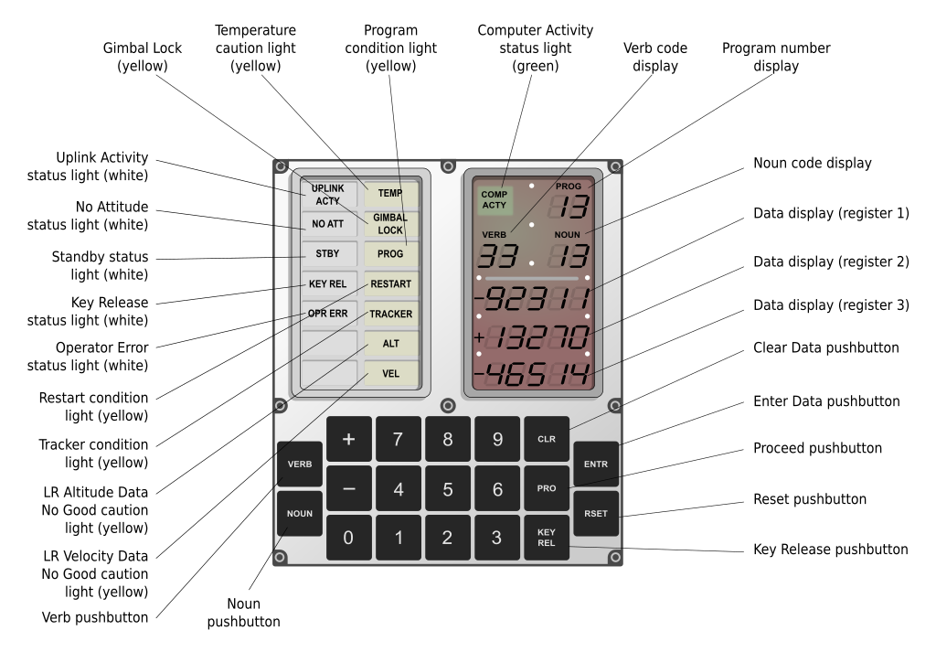

## THE CHALLENGE

**In Space:**

* No GPS satellites
* No road signs
* No landmarks
* No "up" or "down"
* 240,000+ miles from Earth
* Traveling 20,000+ mph
* Must aim for target smaller than a dime at 100 feet

The Question: How do you know where you are and where you're going?

## METHOD #1: STAR SIGHTING (NORMAL PROCEDURE)

The Principle: Stars Are Fixed Reference Points

**The Alignment Optical Telescope (AOT):**

* Built into Lunar Module
* High-precision telescope
* Sights on specific known stars
* Computer calculates spacecraft orientation

**Standard Procedure:**

1. Astronaut looks through telescope

2. Identifies two specific stars (from catalog)

3. Centers each star in crosshairs

4. Computer calculates platform alignment

5. Knows exactly which way spacecraft is pointing

**Why It Works:**

* Stars are SO FAR away they appear fixed
* Star positions known with extreme precision
* Same stars visible from anywhere in solar system
* Like using North Star for navigation on Earth

Accuracy: Extremely high (~0.5 degrees)

**The Apollo 13 Problem:**

❌ Debris field from explosion created "sparklies"

❌ Ice crystals and metal fragments glitter like stars

❌ Impossible to tell which points of light are real stars

❌ Could misalign platform completely

❌ Standard procedure UNUSABLE

## METHOD #2: SUN/EARTH TERMINATOR (EMERGENCY BACKUP)

**The Apollo 13 Solution:**

**What They Used:**

1. The Sun (viewed in AOT - Alignment Optical Telescope)

2. Earth's terminator (viewed in COAS - Crew Optical Alignment Sight)

**Why It Worked:**

* Sun is UNMISTAKABLE (brightest object, can't confuse it)
* Earth's terminator (day/night line) clearly visible
* Two large targets instead of tiny stars
* No confusion with debris

**The Terminator:**

* Line between day and night on Earth
* Clearly visible from space
* Sharp contrast between light/dark
* Acts as reference line for orientation

**The Procedure (GET ~73:46):**

1. Position Sun in center of AOT reticle

2. Simultaneously position Earth's terminator in COAS

3. Use both instruments at same time

4. Cross-reference to determine orientation

5. "Good enough" for course corrections

**Crew Optical Alignment Sight (COAS):**

* Simple telescope mounted in window
* Crosshairs for precise aiming
* Hand-held or mounted
* Used for docking, now for navigation

Accuracy: Lower than stars (~2-3 degrees) but GOOD ENOUGH

**Jim Lovell's Skill:**

* Years of experience
* Steady hands in zero gravity
* Manual alignment under pressure
* Perfect execution

Result: PC+2 burn successful, trajectory on target

## METHOD #3: INERTIAL MEASUREMENT UNIT (IMU)

**The Platform:**

**What It Is:**

* Gyroscope-based platform
* "Remembers" spacecraft orientation
* Updated by star sightings or manual alignment
* Provides continuous attitude reference

**How Gyroscopes Work:**

* Spinning mass resists changes to orientation
* Three gyros for X, Y, Z axes
* Acts as stable platform in space
* Like inner ear for balance on Earth

**The Problem:**

* Gyros drift over time (loses accuracy)
* Must be re-aligned periodically
* Normally use star sightings
* Apollo 13 used Sun/Earth instead

**Platform Alignment:**

* "Tells" IMU which way is which
* IMU then tracks all movements
* Computer uses IMU data for navigation
* Critical for automatic guidance

## METHOD #4: GROUND TRACKING

**Mission Control's View:**

**Tracking Stations:**

* Radio antennas around the world
* Measure radio signals from spacecraft
* Calculate distance and velocity
* Doppler shift shows speed toward/away

**The Math:**

* Measure signal strength (distance)
* Measure frequency shift (velocity)
* Calculate position from multiple stations
* Predict trajectory

**Ground-Based Navigation:**

* Mission Control tracks spacecraft
* Radios up course corrections
* Backup to onboard systems
* Very accurate but delayed

**Apollo 13 Use:**

✅ Mission Control tracked continuously

✅ Calculated trajectory corrections

✅ Radioed instructions to crew

✅ Double-checked crew's manual alignments

## METHOD #5: VISUAL LANDMARKS

**Earth and Moon as References:**

**Earth:**

* Visible from 240,000 miles away
* Terminator (day/night line) clear
* Can estimate direction and distance
* Not precise but useful

**Moon:**

* Visible during approach and departure
* Craters can be identified
* Used during lunar orbit
* Apollo 13 saw it during flyby

**Spacecraft Attitude:**

* "Barbecue roll" - slow rotation for thermal control
* Keeps one side from overheating
* Crew can see Earth/Moon through windows
* Helps maintain situational awareness

## THE INSTRUMENTS

**AOT - Alignment Optical Telescope (LM):**

* Location: Built into LM roof
* Purpose: Sight on stars for navigation
* Magnification: 6x or 60x
* Apollo 13: Used for Sun alignment

**COAS - Crew Optical Alignment Sight:**

* Location: LM window mount
* Purpose: Docking alignment, now navigation
* Features: Crosshairs, hand-held or mounted
* Apollo 13: Used for Earth terminator

**Sextant (CM):**

* Location: Command Module telescope
* Purpose: Star sightings, angle measurements
* Not used on Apollo 13 (CM powered down)

## NAVIGATION CHALLENGES ON APOLLO 13

**The Problems:**

❌ Can't use stars (debris field)

❌ Can't use CM sextant (powered down)

❌ Must use backup methods

❌ Manual alignment less accurate

❌ Every course correction critical

**The Solutions:**

✅ Sun/Earth terminator alignment

✅ Ground tracking from Mission Control

✅ Jim Lovell's skill and experience

✅ IMU maintained between alignments

✅ Multiple mid-course corrections

**The Burns:**

1. GET 61:29:42 - Free-return DPS burn (~31 sec)

2. GET 79:27:40 - PC+2 burn (4½ min, ~900 ft/s)

3. GET ~105:18 - Manual mid-course tweak (~7-8 ft/s)

All successful with manual navigation!

## COURSE CORRECTION PROCESS

**Step-by-Step:**

**1. Alignment:**

• Position Sun in AOT

• Position Earth terminator in COAS

• Tell computer current orientation

**2. Calculation:**

• Computer calculates required burn

• Duration, direction, engine power

• Ground Control double-checks

**3. Orientation:**

• Point spacecraft in correct direction

• Use hand controller to aim

• Verify alignment visually

**4. Burn:**

• Fire descent engine (DPS)

• Monitor duration precisely

• Shut down at exact moment

**5. Verification:**

• Check new trajectory

• Mission Control confirms

• Make small corrections if needed

## THE MATH OF SPACE NAVIGATION

**Orbital Mechanics:**

**Free-Return Trajectory:**

* Uses Moon's gravity to slingshot back
* No engine needed to change direction
* Predictable physics
* Safe backup plan

**Delta-V (Δv):**

* Change in velocity needed
* Measured in feet per second (ft/s)
* PC+2 burn: ~900 ft/s
* Mid-course: ~7-8 ft/s

**Precision Required:**

* Re-entry corridor: ~2° margin
* Target: -6.2° to -6.5° angle
* Error: Skip off or burn up
* Manual navigation hit the target!

## DID YOU KNOW?

**Navigation Facts:**

* Apollo computer: 64 kilobytes of memory
* Modern smartphone: 1,000,000x more memory
* Yet Apollo 13 made it home with manual alignment
* Jim Lovell logged more space time than any astronaut before Apollo 13
* His experience was critical for manual navigation
* The Sun/Earth terminator method became backup procedure for future missions
* Added to NASA emergency playbook

## THE LESSON

When the perfect system fails,

Improvise with what you have.

When stars are invisible,

Use the Sun.

When computers aren't enough,

Trust human skill.

When everything goes wrong,

Work the problem.

Navigation saved Apollo 13.

🌟 → ☀️ → 🌍 → 🏠

**THEY FOUND THEIR WAY HOME.**

DECISION POINT #4

# BUILD THE CO2 MAILBOX?

*GET ~90:00:00 | Rising Carbon Dioxide Crisis*

*[Image: slide11_mailbox.jpg]*

## THE SITUATION

* CO2 levels rising dangerously in the LM (approaching ~15 mmHg—deadly)
* LM's lithium hydroxide (LiOH) canisters are ROUND, sized for 2 people for 2 days
* Now supporting 3 people for ~4 days—LM scrubbers running out of capacity
* Command Module has extra SQUARE LiOH canisters (unused)
* Problem: Square canisters won't fit in round LM receptacles
* Available materials: plastic bags, cardboard, duct tape, hoses, flight manual covers

## OPTION 1: DO NOTHING BUT REST

Subtitle: Reduce physical activity to slow CO2 production

**PROS:**

* Uses existing systems—no construction needed
* No risk of adapter failure
* Conserves energy for crew
* Simple approach

**CONS:**

* Not enough—CO2 will still keep rising to deadly levels
* High CO2 impairs judgment and decision-making
* Could lose consciousness before realizing danger
* Death by CO2 poisoning within hours
* No backup plan if this fails

## OPTION 2: BUILD "MAILBOX" ADAPTER

Subtitle: Create square-to-round adapter using onboard materials

**PROS:**

* Uses CM's fresh square lithium hydroxide canisters
* Can sustain 3 people for entire journey
* Only solution that actually removes CO2
* Materials are available on board

**CONS:**

* Never attempted before—completely improvised
* Uncertain if materials will seal properly
* Duct tape and plastic might not hold vacuum
* Failure means death—no second chance
* Requires precision assembly in zero-g

## DECISION PROMPT

**🤔 WHAT SHOULD THE CREW DO?**

## HISTORICAL DECISION

NASA chose BUILD THE MAILBOX

* Mission Control engineers designed solution using only materials aboard
* Crew built adapter using:

- Square CM lithium hydroxide canisters

- Plastic bags

- Cardboard from flight manual covers

- Duct tape (lots of it!)

- Hoses

* CO2 dropped from ~14.9 mmHg to ~4.6 mmHg—back to safe levels
* Lifesaving ingenuity—solution saved crew's lives
* Proved that "duct tape fixes everything," even in space

INFO SLIDE #5

# THE MAILBOX

*Duct Tape, Cardboard, and Genius*

## THE CO2 CRISIS

**The Problem:**

**Carbon Dioxide (CO2) Levels Rising:**

* Humans exhale CO2 with every breath
* In sealed spacecraft, CO2 accumulates
* High CO2 = headaches, nausea, unconsciousness, death
* Deadly level: ~15 mmHg partial pressure
* Apollo 13 approaching ~15 mmHg

**The Numbers:**

* LM designed for: 2 people for 45 hours
* Apollo 13 reality: 3 people for 87+ hours
* That's 2.9x the CO2 production!

**Symptoms of High CO2:**

* Headaches
* Dizziness
* Difficulty breathing
* Impaired judgment
* Unconsciousness
* Death

Time to Crisis: Hours, not days

## THE SCRUBBER MISMATCH

**How CO2 Scrubbers Work:**

**Lithium Hydroxide (LiOH) Canisters:**

* Chemical that absorbs CO2 from air
* Air blown through canister
* CO2 chemically binds to LiOH
* Clean air comes out
* Eventually saturates (must replace)

**The Shape Problem:**

* LM canisters: ROUND (cylindrical)
* CM canisters: SQUARE (rectangular)
* Different sizes, different connections
* NOT interchangeable by design

**The Inventory:**

* LM has: Limited round canisters (running out)
* CM has: Plenty of fresh square canisters (unused)
* Problem: Square peg won't fit in round hole

**The Cruel Irony:**

* Plenty of fresh scrubbers on board
* Just can't use them
* Like having food you can't open
* Crew could suffocate with solution 10 feet away

## THE MISSION CONTROL SCRAMBLE

GET ~90:00:00 - Engineers Attack the Problem

**The Challenge to Engineers:**

"We've got to find a way to make THIS..."

[holds up square CM canister]

"...fit into the hole for THIS..."

[holds up round LM canister]

"...using nothing but THAT."

[dumps out materials available on spacecraft]

**Available Materials on Apollo 13:**

✅ Plastic bags (food storage)

✅ Cardboard (from flight manual covers)

✅ Duct tape (gray tape, lots of it)

✅ Hoses (from LM systems)

✅ Suit hoses (from spacesuits)

✅ Towels

✅ Bungee cords

**NOT Available:**

❌ Special tools

❌ Glue or sealants

❌ 3D printer

❌ Machine shop

❌ Hardware store

**The Engineering Team:**

* Work around the clock
* Build prototype on ground using EXACT same materials
* Test for air leaks
* Design step-by-step instructions
* Must work in zero gravity
* Must work first time - no second chance

## THE MAILBOX DESIGN

The Concept: Force Air Through Square Canister

**Components:**

1. Square CM lithium hydroxide canister (the filter)

2. Plastic bag (sealed chamber around canister)

3. Cardboard (structural support and air ducting)

4. Duct tape (seals everything together)

5. Hose (connects to LM air circulation system)

**How It Works:**

1. Seal square canister inside plastic bag

2. Cut hole in plastic bag for air inlet

3. Attach hose to bag for air outlet

4. Use cardboard to create air duct

5. Tape everything together (LOTS of tape)

6. Connect to LM's air circulation fan

7. Fan pulls air through makeshift scrubber

8. Clean air returns to cabin

Why "Mailbox"?

* Shape looked like rural mailbox
* Square opening with connection on side
* Nickname stuck

## THE BUILD PROCEDURE

**Mission Control Radioed Instructions:**

Step 1: Gather Materials

"Okay, we need you to find the following items..."

* 2 square LiOH canisters from CM stowage
* Large plastic bag
* Flight manual cover (cardboard)
* Duct tape roll
* Suit hose

Step 2: Prepare the Canister

* Place square canister in plastic bag
* Position canister for air flow
* Ensure proper orientation

Step 3: Create Air Path

* Cut hole in plastic bag
* Insert hose into hole
* Seal around hose with tape

Step 4: Cardboard Support

* Cut cardboard from manual cover
* Create duct for air flow
* Tape to bag structure

Step 5: Seal Everything

* Duct tape around all seams
* Check for air leaks
* Reinforce connections
* Use MORE tape (can't have too much!)

Step 6: Connect to LM System

* Attach hose to LM air circulation
* Position mailbox securely
* Turn on circulation fan

Step 7: Monitor CO2 Levels

* Watch gauges anxiously
* Wait for CO2 to drop
* Pray it works

Build Time: ~1 hour of careful assembly

## THE RESULT

**Moment of Truth:**

CO2 Level Before Mailbox: ~14.9 mmHg (near-deadly)

CO2 Level After Mailbox: ~4.6 mmHg (safe!)

Drop: 10.3 mmHg in minutes

Time to Safe Levels: Less than 1 hour

Success Rate: 100%

**The Crew's Reaction:**

* Relief and amazement
* Headaches clearing
* Breathing easier
* Crisis averted

Jim Lovell: "We have a mailbox!"

## THE MATERIALS BREAKDOWN

**What Each Component Did:**

**Plastic Bag:**

* Created sealed chamber
* Forced air through canister
* Prevented leaks to space

**Cardboard:**

* Structural support
* Directed air flow
* Lightweight and available

**Duct Tape:**

* Sealed all connections
* Held assembly together
* Airtight seal
* The real hero of Apollo 13

**Hose:**

* Connected mailbox to LM fan
* Carried clean air back to cabin
* Flexible for positioning

**Square Canister:**

* Fresh lithium hydroxide
* Absorbed CO2 from air
* Plenty available in CM

## WHY IT WORKED

**Engineering Principles:**

**Pressure Differential:**

* LM fan creates suction
* Pulls air through mailbox
* Forces air through LiOH canister
* Returns clean air to cabin

**Seal Integrity:**

* Duct tape creates airtight seal
* Plastic bag contains air flow
* No leaks to space (vacuum outside)

**Chemical Process:**

* LiOH + CO2 → Lithium Carbonate
* Chemical reaction absorbs CO2
* Process works regardless of canister shape
* Just need air to flow through

**Human Ingenuity:**

* Problem-solving under pressure
* Using what's available
* Testing before execution
* Clear communication Earth ↔ Space

## THE LEGACY

**What the Mailbox Represented:**

**🧠 Intelligence:**

* Engineers solved impossible problem
* Used only materials on board
* Designed in hours, not months

**🤝 Teamwork:**

* Mission Control designed
* Crew built
* Perfect coordination
* Trust between Earth and space

**🛠️ Ingenuity:**

* No fancy equipment needed
* Duct tape and cardboard
* Sometimes simple is best
* "Work with what you have"

**⏱️ Speed:**

* CO2 rising fast
* Designed solution in hours
* Built in ~1 hour
* Worked immediately

## DUCT TAPE IN SPACE

**The Universal Fix:**

**Why Duct Tape Works in Space:**

✅ Adhesive works in vacuum

✅ Strong and flexible

✅ Airtight seal

✅ Easy to use in zero gravity

✅ Doesn't outgas (release chemicals)

**Apollo 13 Duct Tape Uses:**

* Sealed mailbox adapter
* Repaired other systems
* Held equipment in place
* Temporary fixes everywhere

**Every Mission After:**

* Extra duct tape added to manifest
* "If duct tape can't fix it, nothing can"

## DID YOU KNOW?

**Mailbox Facts:**

* Original ground prototype is in Smithsonian museum
* Actual flight mailbox burned up during re-entry (in LM)
* Procedure added to all future Apollo missions
* Inspired MacGyver TV show decades later
* CO2 stayed at safe levels for entire journey home
* Second mailbox built as backup (never needed)
* The square/round mismatch was known before flight
* But nobody thought LM would be lifeboat for 4 days
* Design assumption: LM used for 45 hours max

## THE LESSON

When perfect solutions aren't available,

Improvise with what you have.

When fancy equipment fails,

Use duct tape and cardboard.

When time is running out,

Stay calm and work the problem.

When CO2 is killing you,

Build a mailbox.

🟥 Square Canister

🔵 Round Hole

🎨 Duct Tape

✅ Problem Solved

THEY COULD BREATHE. THEY COULD SURVIVE. THEY COULD GO HOME.

DECISION POINT #5

# WATER CONSERVATION STRATEGY

*GET ~85:00:00 | Critical Water Shortage*



## THE SITUATION

* Water supplies critically low
* Water needed for three vital purposes:

1. Drinking water for crew (survival)

2. Cooling systems for electronics (prevents overheating/fire)

3. Humidification for breathing (prevents lung damage)

* Current consumption rate: will run dry 18 hours before splashdown
* Must drastically reduce usage or risk death/equipment failure

## OPTION 1: EQUAL RATIONING

Subtitle: Distribute water evenly across all three systems

**PROS:**

* Balanced approach—no single system completely fails
* Maintains all systems partially functional
* Democratic distribution of scarce resource
* Reduces guilt over prioritization decisions

**CONS:**

* All three systems degraded simultaneously
* Moderate crew dehydration affects judgment
* Moderate equipment risk of overheating
* Moderate breathing discomfort
* May not save enough—could lose everything

## OPTION 2: PRIORITIZE DRINKING WATER

Subtitle: Give crew adequate water, minimize cooling/humidification

**PROS:**

* Crew stays hydrated and alert for critical decisions
* Sharp minds for re-entry procedures
* Humans can survive dry air temporarily
* Crew comfort maximized

**CONS:**

* Electronics risk overheating and failure
* Air becomes painfully dry
* Potential equipment fires
* Could lose navigation/guidance systems
* Breathing discomfort causes fatigue

## OPTION 3: PRIORITIZE EQUIPMENT COOLING

Subtitle: Keep electronics safe, minimize drinking water

**PROS:**

* Prevents electrical fires
* Maintains navigation and guidance systems
* Ensures re-entry computer functionality
* Equipment reliability maximized

**CONS:**

* Severe crew dehydration (dangerous)
* Impaired judgment and decision-making
* Physical weakness for re-entry procedures
* Crew might not survive to use equipment
* Medical complications from dehydration

## DECISION PROMPT

**🤔 WHAT SHOULD THE CREW DO?**

## HISTORICAL DECISION

NASA chose EXTREME RATIONING—prioritize survival

* Reduced to 6 ounces of water per person per day (normal: 64 oz)
* That's less than 1 cup per day!
* Minimal equipment cooling—accepted risk of overheating
* Minimal humidification—crew endured dry, painful breathing
* Combined crew weight loss: 31.5 pounds
* Haise developed kidney infection from dehydration
* Systems held together just long enough to get home

INFO SLIDE #6

# SURVIVAL CONDITIONS

*Four Days in a Freezing, Cramped Lifeboat*

## THE LUNAR MODULE AS LIFEBOAT

Designed For: 2 astronauts, 45 hours (Moon landing mission)

Apollo 13 Reality: 3 astronauts, 87+ hours (4 days in space)

That's 2.9x the intended use!

## TEMPERATURE: THE FREEZING CHALLENGE

**The Cold Reality:**

**Inside Aquarius:**

* Temperature: 38°F (3°C) minimum
* Some areas: 50°F
* Colder than a refrigerator
* Below freezing in some spots

Why So Cold?

* Power conservation = minimal heaters
* Electronics powered down to save batteries
* Service Module damaged (no heat from there)
* Space is -455°F (-270°C) all around
* Only thin aluminum walls for insulation

**What the Crew Experienced:**

❄️ Shivering constantly (can't get warm)

❄️ Numb fingers and toes

❄️ Difficulty sleeping (too cold)

❄️ Water condensation on every surface

❄️ Ice forming on windows and equipment

❄️ Can see breath in cabin air

❄️ Frostbite risk on extremities

**Condensation Problem:**

* Crew breathing creates moisture
* Cold walls cause condensation
* Water droplets float in zero gravity
* Equipment could short-circuit
* Constant worry about electrical systems

**Medical Impact:**

* Hypothermia risk
* Slowed reactions and thinking
* Reduced immune system function
* Fred Haise's kidney infection worsened by cold

**No Warm Clothing:**

* Only thin flight suits
* No space for heavy jackets
* Spacesuits too bulky to wear constantly
* Just had to endure the cold

## WATER: SEVERE RATIONING

**The Water Crisis:**

Normal Consumption: 64 oz per person per day (8 cups)

Apollo 13 Ration: 6 oz per person per day (3/4 cup)

That's 1/10th of normal water intake!

**Water Uses on Spacecraft:**

1. Drinking (crew survival)

2. Cooling electronics (prevents overheating/fires)

3. Humidifying air (prevents lung damage from dry air)

**The Rationing Decision:**

* Prioritize crew survival (minimal drinking water)
* Minimal electronics cooling (accept risk)
* Minimal humidification (painful but survivable)

**What 6 Ounces Looks Like:**

* Less than 1 cup total per day
* 2-3 small sips every few hours
* Barely enough to swallow food
* Severe dehydration guaranteed

**Effects of Dehydration:**

🥵 Extreme thirst (dry mouth, cracked lips)

🥵 Dizziness and lightheadedness

🥵 Impaired judgment and confusion

🥵 Physical weakness

🥵 Kidney stress (Fred Haise's infection)

🥵 Dark urine (concentrated)

🥵 Headaches

**Medical Consequences:**

* Combined weight loss: 31.5 pounds total

- Jim Lovell: 14 lbs

- Jack Swigert: 5 lbs

- Fred Haise: 6 lbs (+ kidney infection)

* Dehydration weakened crew for re-entry
* Recovery took weeks after splashdown

**The Psychological Torture:**

* Water available in CM (powered down, can't access)
* LM water limited (must last entire trip)
* Every drop counted
* Watching each other's consumption

## POWER: EVERY AMP MATTERS

**The Battery Crisis:**

**LM Battery Capacity:**

* Designed for 45-hour lunar mission
* Now supporting 87+ hours (double!)
* Used for life support, navigation, communications

**Power Budget:**

* Calculated down to individual amps
* Every system evaluated: essential or not?
* Continuous monitoring of remaining power
* 20% remaining at splashdown (cutting it close!)

**What Was Powered Down:**

❌ Heaters (except critical components)

❌ Most cabin lights

❌ Non-essential electronics

❌ Communications (reduced to minimum)

❌ Guidance computer (except during burns)

**What Stayed On:**

✅ Life support (oxygen circulation)

✅ Minimal lighting (stumbling in dark)

✅ CO2 scrubbers (critical)

✅ Attitude control (spacecraft orientation)

✅ Communications (essential updates only)

**The Communication Dilemma:**

* Each radio transmission drains batteries
* Families desperate for updates
* Crew feels isolated
* Some silence periods: 6+ hours
* Mission Control flying blind

**Radio Discipline:**

* Essential updates only
* No casual conversation
* Families terrified during long silences
* Crew felt abandoned but understood

**Battery Jump-Start (GET ~138:00:00):**

* Transfer power from LM to CM
* Never tested before
* Risk of short-circuit
* Worked perfectly!
* Charged CM batteries for re-entry

## FOOD: MINIMAL NUTRITION

**The Food Problem:**

**Available Food:**

* Freeze-dried packets
* Required water to prepare (don't have water!)
* Some "wet pack" foods available
* Limited variety

**Consumption Reality:**

* Hard to eat in extreme cold
* Dry food hard to swallow without water
* Stress kills appetite
* Forcing down calories

**Nutrition Impact:**

* Calorie deficit (burning more than eating)
* Weight loss from dehydration + malnutrition
* Weakened for re-entry tasks
* Mental fog from hunger + cold + stress

## SLEEP: NEARLY IMPOSSIBLE

**The Sleep Deprivation Crisis:**

**Why Sleep Was Impossible:**

😴 Temperature too cold to relax

😴 Cramped quarters (moving wakes others)

😴 Constant stress and worry

😴 Uncomfortable in zero gravity

😴 Noise from systems and alarms

😴 Bright sunlight through windows

😴 No day/night cycle in space

**Sleep Attempts:**

* Brief naps (minutes, not hours)
* Never deep sleep
* Constantly startled awake
* Exhaustion building

**Effects of Sleep Deprivation:**

* Impaired judgment
* Slowed reactions
* Irritability
* Difficulty concentrating
* Mistakes more likely
* Dangerous during critical re-entry

**Jim Lovell's Experience:**

* Fourth spaceflight (used to discomfort)
* But worst conditions ever
* Pushed through on experience
* Leadership required alertness

**Rookies Swigert & Haise:**

* First spaceflight
* Expected Moon landing adventure
* Got survival nightmare instead
* Performed admirably under stress

## OXYGEN: THE ONE BRIGHT SPOT

**Oxygen Status:**

**LM Oxygen Supply:**

✅ Sufficient for 3 people for journey

✅ CO2 scrubbers working (thanks to mailbox)

✅ Breathing not a problem (after mailbox fix)

**Oxygen Storage:**

* Stored in LM descent stage tanks
* Separate from damaged SM tanks
* Enough capacity for extended mission

**The Relief:**

* At least they could breathe
* CO2 controlled at ~4.6 mmHg (safe)
* One less thing to worry about

## SPACE: CRAMPED QUARTERS

**The Physical Constraints:**

**Lunar Module Interior:**

* ~160 cubic feet (like walk-in closet)
* Designed for 2 standing astronauts
* Now holding 3 people
* NO SEATS (standing room only)

**The Reality:**

* Can't stretch out
* Bumping into each other constantly
* Moving disturbs everyone
* No privacy whatsoever
* Personal space: zero

**Zero Gravity "Helps":**

* Can float in any orientation
* Not standing on feet for days
* But still cramped
* Equipment everywhere

## WASTE MANAGEMENT

**The Uncomfortable Reality:**

**Bathroom Facilities:**

* Urine collection bags
* Fecal collection bags
* No privacy
* Difficult in zero gravity

**With Dehydration:**

* Less urine (darker, concentrated)
* Uncomfortable but less frequent
* Fred Haise's kidney infection made it painful

**The Psychological Toll:**

* No privacy for 4+ days
* Three men in tiny space
* Personal hygiene impossible
* Just had to endure

## CUMULATIVE EFFECTS

**The Total Stress on Crew:**

**Physical:**

❄️ Freezing temperature (38°F)

💧 Severe dehydration (6 oz water/day)

😴 Sleep deprivation (minimal sleep for 4+ days)

🍽️ Malnutrition (limited food)

🤒 Illness (Haise's kidney infection)

😰 Exhaustion (complete physical drain)

**Mental:**

🧠 Stress (life-or-death situation)

😟 Isolation (long radio silences)

😨 Fear (will we make it?)

🎯 Pressure (must execute perfectly)

😤 Frustration (constant discomfort)

**Yet They Performed:**

✅ Built mailbox adapter

✅ Executed navigation burns

✅ Monitored systems continuously

✅ Made critical decisions

✅ Stayed calm under pressure

✅ Landed safely

## COMPARISON TO ENDURANCE RECORDS

**Apollo 13 vs Other Extremes:**

**Antarctic Explorers:**

* Have warm shelters
* Have adequate food and water
* Can move around
* Ground beneath feet

**Mountain Climbers:**

* Can turn back
* Rescue possible
* Fresh air to breathe
* Gravity works normally

**Submarine Crews:**

* More space
* Adequate resources
* Can surface if needed
* Crew rotation for sleep

**Apollo 13:**

* NO warm shelter (38°F)
* NO adequate water (6 oz/day)
* NO room to move (160 cu ft)
* NO rescue possible
* NO turning back
* Must execute perfectly or die

## THE HUMAN SPIRIT

**What They Proved:**

**Humans Can Survive:**

* 4+ days at 38°F
* Severe dehydration
* Complete sleep deprivation
* Extreme stress and fear
* Cramped, uncomfortable conditions

**When Motivated By:**

* Desire to live
* Trust in team
* Professional training
* Calm problem-solving
* Refusal to give up

Gene Kranz: "Failure is not an option."

Crew's Actions: Proved it.

## THE RECOVERY

**After Splashdown:**

**Immediate Medical Care:**

* Rehydration (IV fluids)
* Warming (heated blankets)
* Rest (finally!)
* Medical monitoring

**Recovery Time:**

* Weeks to fully recover
* Fred Haise: Kidney infection treated
* Weight gain back to normal
* Psychological impact: lifelong

## THE LESSON

The human body can endure incredible hardship.

The human spirit can overcome impossible odds.

When you have to survive,

You find a way.

When comfort isn't an option,

Endure.

When sleep is impossible,

Stay alert.

When water runs out,

Ration.

When it's freezing,

Shiver and continue.

Four days in hell.

Three men survived.

🥶 + 💧 + 😴 + 🚀 = 🏠

**THEY MADE IT HOME.**

DECISION POINT #6

# SPEED UP BURN (PC+2)?

*GET 79:27:40 | Wrong Ocean Landing Zone*

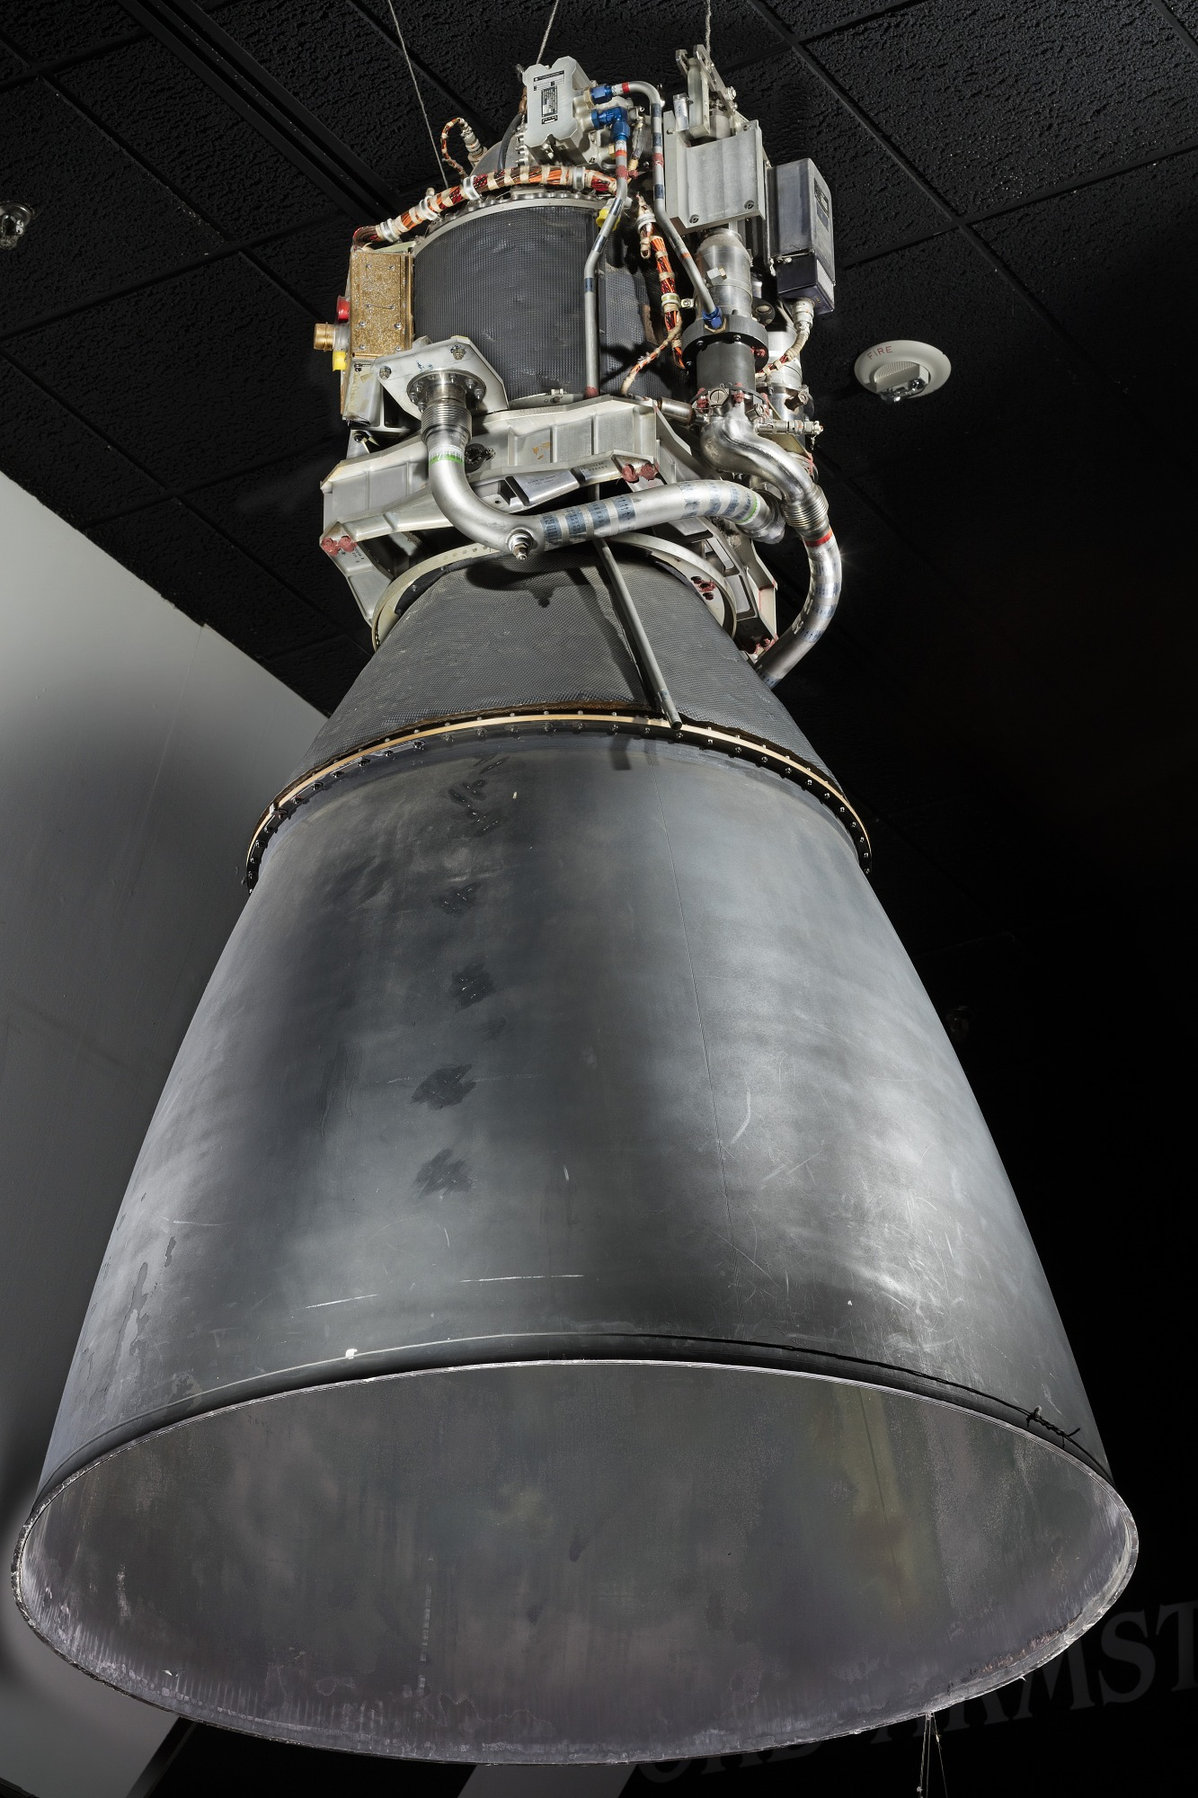

## THE SITUATION

* Free-return trajectory will get them home, but too late and in wrong ocean
* Current path would land far from recovery ships (wrong ocean)
* Solution: Major burn 2 hours after pericynthion (PC+2) to speed up and retarget
* Risk: LM Descent Engine will run for 4½-5 minutes in deep space
* Longest burn yet—within design limits but high-stakes

## OPTION 1: COAST ON FREE-RETURN

Subtitle: Accept current trajectory—no additional burn

**PROS:**

* No risk of engine failure during critical burn
* Conserves fuel for emergency corrections
* Simple—no complex maneuvers
* Systems already stressed—why add more risk?

**CONS:**

* Longer mission time (~9-10 hours extra)
* Lands in wrong ocean, far from recovery fleet
* More time for systems to fail
* Longer exposure to cold, dehydration, CO2
* Recovery ships must reposition—delays rescue

## OPTION 2: PERFORM PC+2 BURN

Subtitle: Fire LM descent engine for extended burn to retarget

**PROS:**

* Cuts ~9-10 hours off return time
* Targets Pacific recovery zone near USS Iwo Jima
* Less time for systems to fail
* Faster medical attention for crew
* Ships already positioned and waiting

**CONS:**

* Long engine burn (4½-5 minutes) stresses systems
* Uses significant fuel (~900 ft/s delta-V)
* Any failure during burn leaves crew stranded
* Engine designed for lunar landing, not deep space burns
* Single point of failure—if engine quits, no backup

## DECISION PROMPT

**🤔 WHAT SHOULD THE CREW DO?**

## HISTORICAL DECISION

NASA chose PERFORM THE PC+2 BURN

* GET 79:27:40 - PC+2 burn using LM descent engine
* Burn duration: ~4½-5 minutes total
* Velocity change: ~900 ft/s of delta-V
* Shortened the trip by ~9-10 hours
* Targeted Pacific recovery zone near USS Iwo Jima
* Engine performed flawlessly—never missed a beat
* Crew grateful for shorter journey in freezing, cramped LM

NARRATIVE SLIDE #4

# THE LONG COLD JOURNEY

*April 15-16, 1970 | Days 5-6, Survival Mode*

## THE MARATHON BEGINS

Days 5-6: April 15-16, 1970

Distance from Earth: Closing, but still 100,000+ miles

Time remaining: ~48 hours to splashdown

Status: Alive, barely

## LIVING CONDITIONS

Inside Aquarius - The Freezing Lifeboat:

Temperature: 38°F (3°C)

* Colder than a refrigerator
* Water droplets condensing on walls
* Ice forming on equipment and windows
* Crew shivering uncontrollably
* Can't sleep—too cold, too cramped

Water Rations: 6 oz per day (less than 1 cup)

* Severe dehydration for all crew
* Fred Haise: kidney/urinary infection developing
* Lips cracked, throats parched
* Dizzy from dehydration
* Combined weight loss: 31.5 pounds total

Food: Minimal

* Too cold to eat much
* Stress kills appetite
* Dry food hard to swallow without water
* Crew forcing down calories

Sleep: Nearly impossible

* Cramped quarters—moving wakes others
* Too cold to relax
* Constant stress and worry
* Exhaustion compounding errors

## THE CO2 CRISIS

GET ~90:00:00 - Mailbox Saves Lives

**The Problem:**

* CO2 rising to dangerous levels (~15 mmHg—deadly)
* LM scrubbers (round) designed for 2 for 2
* Three people breathing for 4+ days
* Headaches, nausea, impaired thinking

**The Solution:**

* Build "mailbox" adapter from spare parts
* Use CM's square scrubbers in LM's round receptacles
* Materials: duct tape, plastic bags, cardboard, hoses
* Mission Control designs it, crew builds it

**The Result:**

* CO2 drops from ~14.9 to ~4.6 mmHg
* Breathable air restored
* Crisis averted with duct tape and ingenuity

## NAVIGATION CHALLENGES

GET ~105:18 - Mid-Course Correction

**Without computer alignment:**

* Use Sun positioned in AOT
* Use Earth's terminator (day/night line) in COAS
* Manual alignment by Jim Lovell
* Small burn: ~7-8 ft/s to fine-tune trajectory
* Targets Pacific splashdown zone

**Challenges:**

* Debris field still creating "sparklies"
* Manual alignment less precise than computers
* One mistake could miss Earth entirely
* Lovell's skill and experience critical

## POWER CRISIS

GET ~110:00:00 - Radio Silence

Battery Status: Critical

* Running on LM batteries designed for short lunar landing
* Every communication drains power
* Need enough for re-entry computers and parachutes

The Decision: Communication discipline

* Reduce radio contact to essentials only
* Some silence periods last 6+ hours
* Families on Earth terrified
* Mission Control flying blind
* Crew feels abandoned but understands

## PSYCHOLOGICAL TOLL

**The Crew:**

Jim Lovell (Commander, age 42)

* Fourth spaceflight, most experienced
* Staying calm, making decisions
* Exhausted but focused

Jack Swigert (CMP, age 38)

* First spaceflight
* Flipped the switch that started it all
* Guilt and stress building
* Working through procedures flawlessly

Fred Haise (LMP, age 36)

* First spaceflight
* Developing kidney infection
* In pain, deteriorating
* Pushing through

## EARTH WATCHES

**Around the World:**

* Families praying for safe return
* Media 24/7 coverage
* Mission Control working in shifts
* Engineers solving problems in real-time
* Public vigils and prayers
* President Nixon promises full rescue efforts

**The Stakes:**

* If they don't make it, NASA may never recover
* Entire Apollo program at risk
* Three lives hanging in balance
* No rescue mission possible
* One chance to get this right

## CRITICAL SYSTEMS STATUS

GET ~136:00:00 - Approaching Earth

Oxygen: Sufficient (thanks to LM reserves)

Water: Nearly exhausted (cutting it close)

Power: Critical (20% remaining)

CO2: Controlled (mailbox working)

Heat: Non-existent (still 38°F)

Crew Health: Deteriorating but functional

Timeline to Splashdown: ~6 hours

**Still to come:**

* Battery jump-start (never tested)
* Service Module jettison (first look at damage)
* LM jettison (saying goodbye to lifeboat)
* CM power-up (will frozen computers work?)
* Re-entry (0.5° margin for error)

NEXT: Powering Up & Jettison

DECISION POINT #7

# COMMUNICATION DISCIPLINE

*GET ~110:00:00 | Battery Power Critical*

*[Image: slide17_mission_control.jpg]*

## THE SITUATION

* Power levels critical—every amp-hour counts
* Radio communication drains precious battery power
* Families on Earth desperate for updates on crew status
* Crew psychologically isolated and stressed in freezing LM
* Mission Control needs periodic status checks
* Batteries must last for re-entry computer and parachute deployment

## OPTION 1: MAINTAIN REGULAR COMMUNICATION

Subtitle: Check in with Mission Control every 2 hours

**PROS:**

* Crew morale supported—feels connected to Earth
* Families reassured that crew is alive
* Mission Control can monitor systems and troubleshoot
* Crew can ask questions and get guidance
* Public stays informed of progress

**CONS:**

* Each transmission drains batteries significantly
* Could lose 5-8% of remaining power with regular comms
* Might not have enough power for re-entry computers
* Radio heater uses power even when not transmitting
* Could die during re-entry due to dead batteries

## OPTION 2: RADIO SILENCE

Subtitle: Minimize communication to emergency-only

**PROS:**

* Conserves maximum power for re-entry
* Ensures computer functionality during critical phases
* Saves power for parachute deployment systems
* More margin for error with remaining batteries
* Power available for unexpected emergencies

**CONS:**

* Crew feels abandoned and alone
* Families terrified—no updates for 12+ hours
* Mission Control can't help if problems develop silently
* Psychological toll on crew is severe
* No guidance for unexpected situations
* Public assumes the worst during silence

## DECISION PROMPT

**🤔 WHAT SHOULD THE CREW DO?**

## HISTORICAL DECISION

NASA chose STRICT COMMUNICATION DISCIPLINE

* Reduced communications to essential status updates only
* Some silence periods lasted 6+ hours
* Families and public endured agonizing waits for news
* Crew felt isolated but understood necessity
* Mission Control blind to real-time problems
* Saved enough power for critical re-entry systems
* Batteries had only ~20% remaining at splashdown
* Close call—wouldn't have made it with regular comms

DECISION POINT #8

# BATTERY JUMP-START?

*GET ~138:00:00 | Dead Batteries for Re-Entry*

## THE SITUATION

* Approaching Earth—Command Module needed for re-entry (only module with heat shield)
* CM batteries drained to 2% during 4-day power-down
* LM has remaining battery power available
* Need to transfer power from LM to CM to charge batteries
* Procedure never tested—could short-circuit both systems
* Without power, CM computers, parachutes, and life support won't function

## OPTION 1: USE ONLY CM RESERVE BATTERIES

Subtitle: Attempt re-entry with 2% battery power

**PROS:**

* No risk of short-circuit damaging systems
* Avoids untested procedure
* Simple—no complex power transfer
* Can't make batteries worse than they are

**CONS:**

* Insufficient power for guidance computers
* Not enough power for parachute deployment
* Life support systems won't function
* Crew will die during re-entry
* 2% power = certain death

## OPTION 2: JUMP-START FROM LM

Subtitle: Connect LM batteries to charge CM systems

**PROS:**

* Can fully charge CM batteries for re-entry
* Provides power for computers and navigation
* Enables parachute deployment systems
* Only option with chance of survival
* LM power otherwise wasted after jettison

**CONS:**

* Never attempted in space—completely improvised
* Could short-circuit both LM and CM systems
* Might electrocute crew through metal hulls
* Could lose ALL remaining power
* Electrical fire risk in oxygen environment
* If it fails, no backup plan

## DECISION PROMPT

**🤔 WHAT SHOULD THE CREW DO?**

## HISTORICAL DECISION

NASA chose ATTEMPT THE JUMP-START

* Houston designed brand-new power-up procedure (never done before)
* Connected LM batteries to CM charging system
* Successfully transferred power without short-circuit
* One CM battery briefly "dropped off the line" but recovered
* Charged CM batteries to sufficient levels for re-entry
* Procedure worked perfectly—added to NASA emergency playbook
* This made re-entry possible—without it, crew would have died

DECISION POINT #9

# SERVICE MODULE JETTISON TIMING

*GET 138:02 | When to Let Go?*

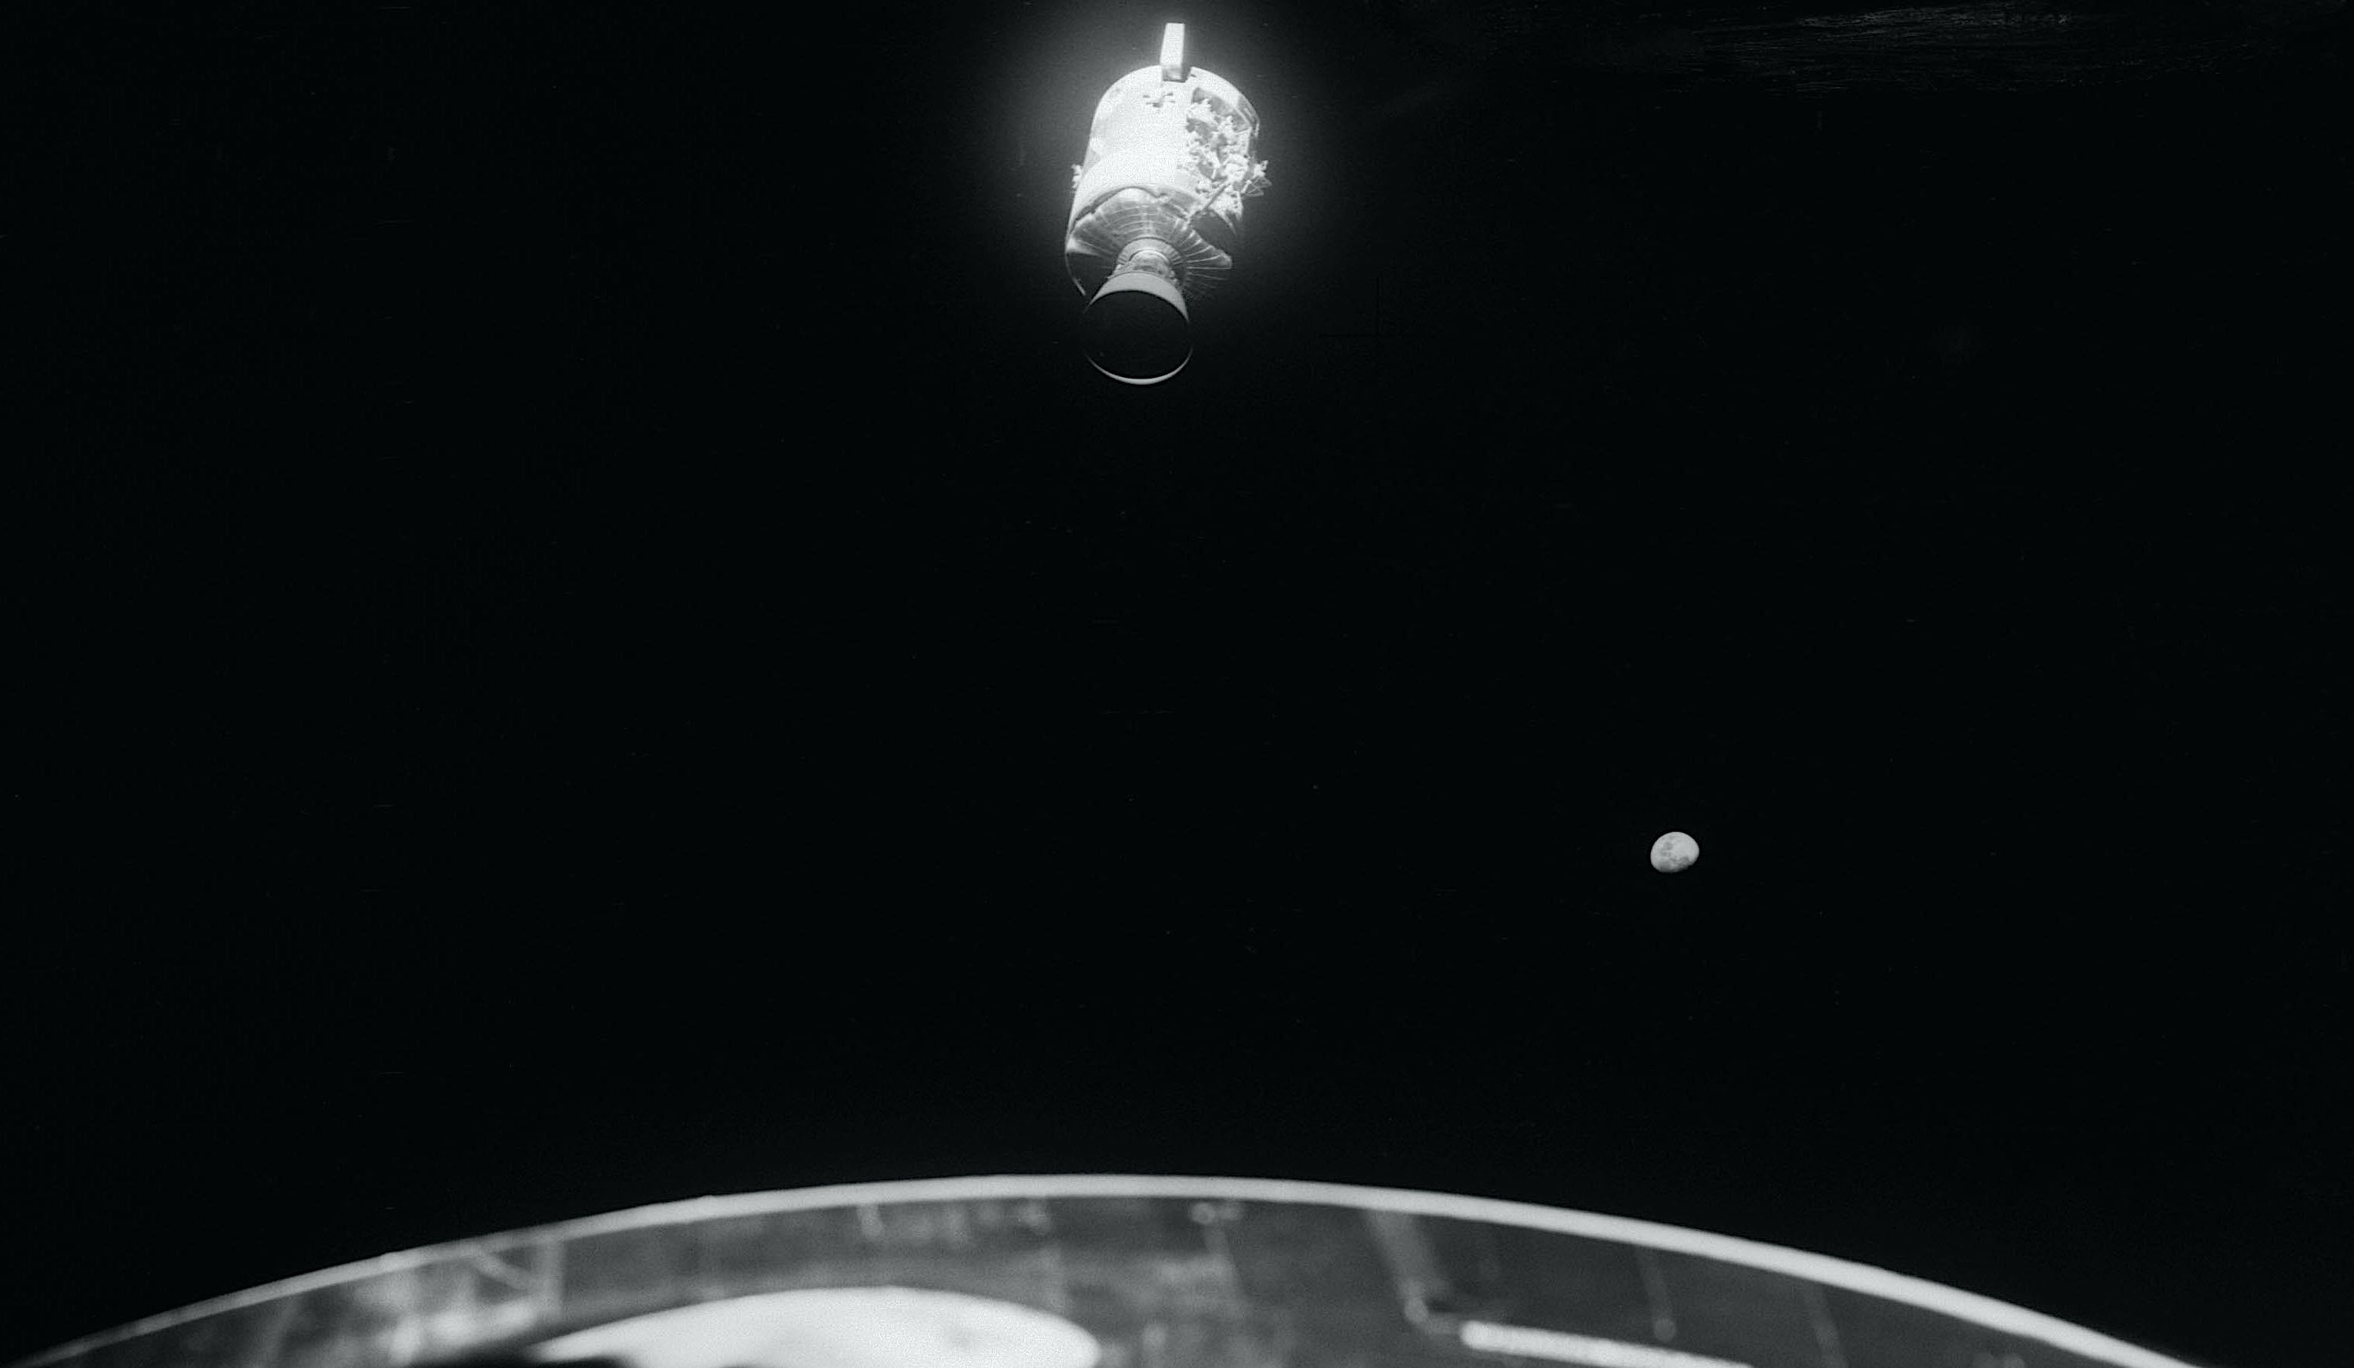

## THE SITUATION

* Approaching re-entry window—must shed weight
* Damaged Service Module still attached to Command Module
* Must jettison SM before re-entry, but timing is critical
* SM provides radiation shielding and thermal protection
* Need to photograph damage for investigation
* Risk of collision if jettison goes wrong

## OPTION 1: EARLY JETTISON

Subtitle: Release SM 6 hours before re-entry

**PROS:**

* Can photograph damage for NASA investigation
* Reduces mass for more accurate trajectory calculations
* Eliminates risk of SM collision during re-entry
* More time to troubleshoot if jettison mechanism fails
* Clear separation before critical phases

**CONS:**

* Crew exposed to more radiation from Van Allen belts
* Lose thermal protection barrier sooner
* Temperatures drop even further (already 38°F)
* More time exposed to cosmic radiation
* Psychological impact of seeing damage

## OPTION 2: LATE JETTISON

Subtitle: Keep SM until 1 hour before re-entry

**PROS:**

* Maximum radiation protection through Van Allen belts
* Thermal barrier against space cold maintained longer
* Crew stays warmer for longer
* Less time for things to go wrong after separation

**CONS:**

* Cannot assess or photograph damage
* Extremely tight timeline if jettison fails
* Risk of SM colliding with CM during separation
* No margin for error—one chance only
* Blind to actual damage until after landing

## DECISION PROMPT

**🤔 WHAT SHOULD THE CREW DO?**

## HISTORICAL DECISION

NASA chose EARLY JETTISON

* GET 138:02 - Jettisoned Service Module
* Crew photographed damage for first time
* Saw entire panel blown off—massive structural damage
* Lovell: "There's one whole side of that spacecraft missing!"
* Explosion had ripped off entire 13-foot panel
* Realized how close they came to complete disaster
* Confirmed they were right to avoid using the SPS engine
* Photos critical for investigating failure and preventing future accidents

NARRATIVE SLIDE #5

# POWERING UP & JETTISON

*April 17, 1970 | Final Preparations for Re-Entry*

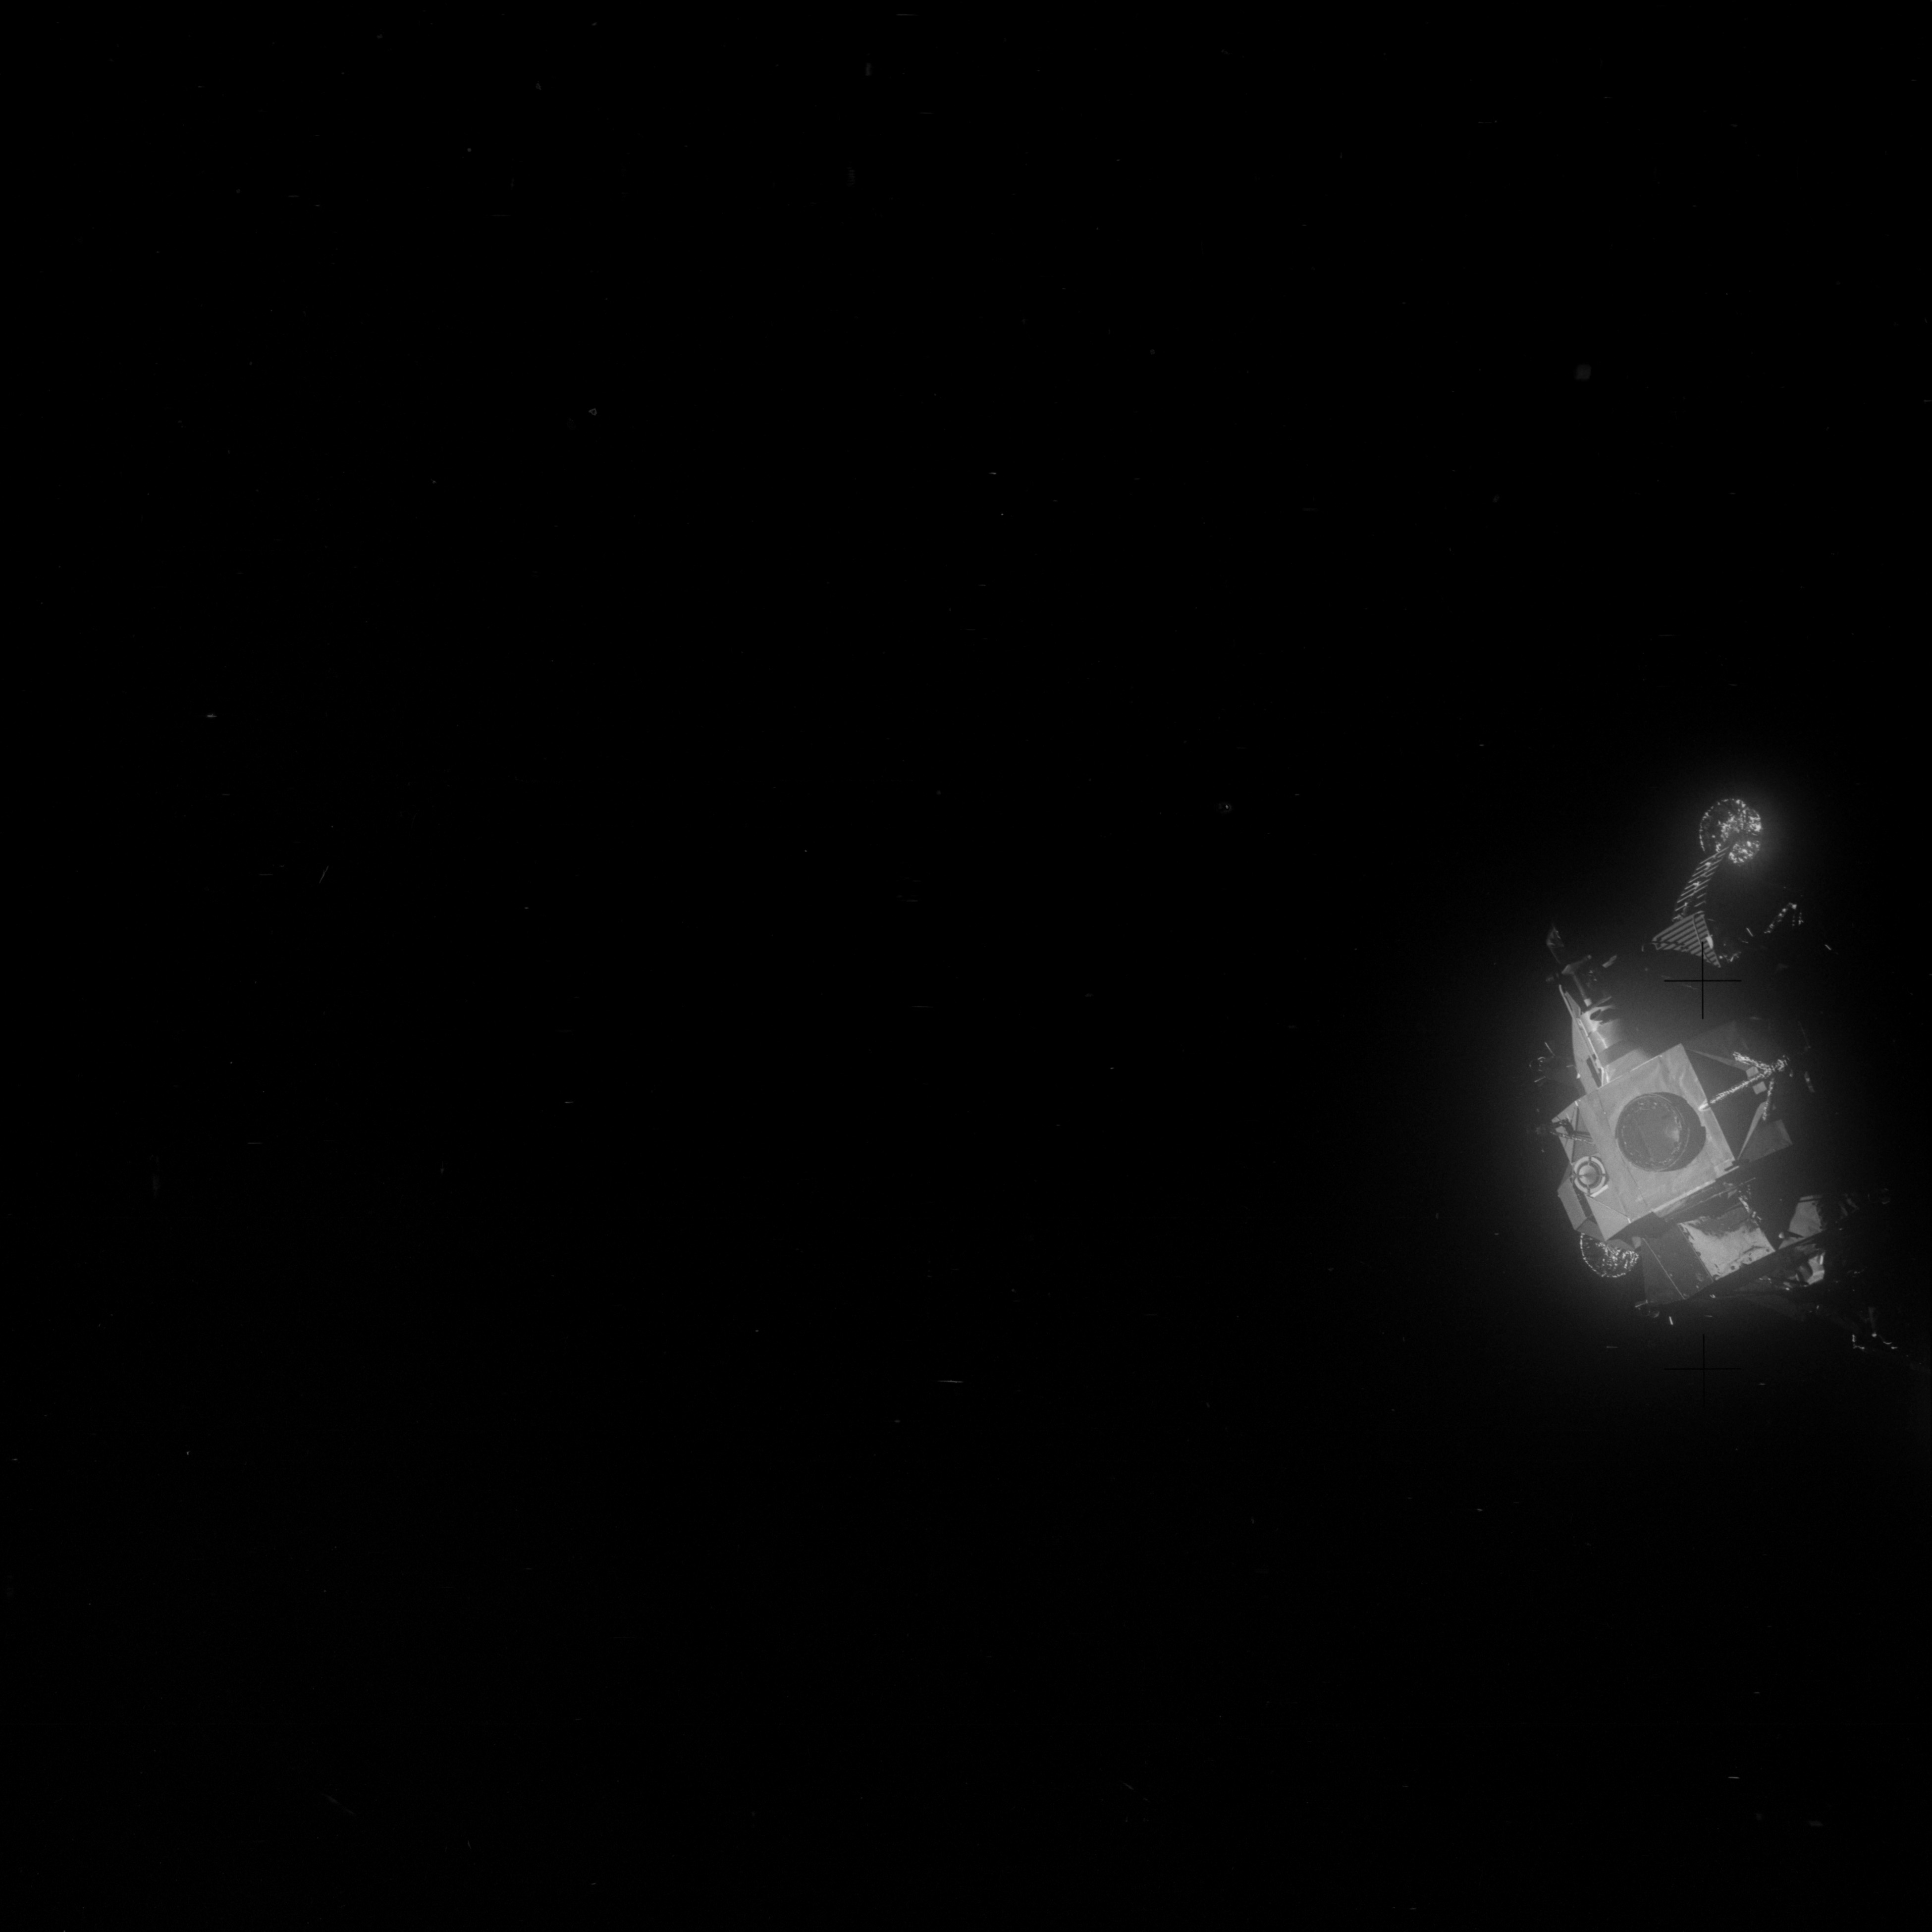

## THE FINAL COUNTDOWN

Day 6 - April 17, 1970

GET ~136:00:00 - 6 hours from splashdown

Status: Alive, approaching Earth

Challenge: Must transition from dead CM to working re-entry spacecraft

## THE BATTERY PROBLEM

GET ~138:00:00 - Jump-Start Procedure

**The Situation:**

* Command Module batteries at 2% power
* Powered down for 4 days to conserve for re-entry
* Need full power for computers, parachutes, life support
* LM has remaining battery power
* Must transfer power LM → CM

**The Risk:**

* Procedure NEVER tested before
* Could short-circuit both systems
* Might electrocute crew
* Could lose all remaining power
* One shot to get it right

**Houston's Innovation:**

* Engineers design brand-new procedure
* Written in real-time for emergency
* Step-by-step power transfer sequence
* Crew follows instructions precisely

**The Result:**

✅ Connection successful!

✅ Power flows from LM to CM batteries

✅ One battery briefly "drops off the line" but recovers

✅ CM batteries charge to sufficient levels

✅ Re-entry now possible

New procedure added to NASA emergency playbook

## SERVICE MODULE JETTISON

GET 138:02 - First Look at the Damage

**The Separation:**

* Pyrotechnic bolts fire
* Service Module drifts away
* Crew sees damage for FIRST TIME
* Cameras ready to photograph

**What They See:**

* Entire 13-foot panel BLOWN OFF
* Massive structural damage visible
* Interior equipment exposed to space
* Wiring and tubing dangling

Jim Lovell: "There's one whole side of that spacecraft missing!"

**The Realization:**

* Explosion was catastrophic
* They were lucky to survive initial blast
* Right decision to avoid using SPS engine
* Could have exploded during critical burn
* Photos will help investigate cause

**Investigation Evidence:**

* Oxygen tank #2 completely destroyed
* Panel ripped from Service Module
* Damage much worse than feared
* Proves how close they came to instant death

## SAYING GOODBYE TO AQUARIUS

GET 141:30 - Lunar Module Jettison

**The Lifeboat's Final Moments:**

* Four days in cramped, freezing quarters
* Aquarius kept three men alive
* Designed for 2 for 2, gave life to 3 for 4
* Now must separate for CM re-entry

**CapCom Joe Kerwin:**

"Farewell, Aquarius, and we thank you."

**The Separation:**

* Crew seals tunnel between LM and CM
* Pyrotechnic bolts fire
* Aquarius drifts away into space
* Last view of their lifeboat

**Crew Emotions:**

* Gratitude for the trusty spacecraft
* Sadness to see it go
* Aquarius will eventually burn up in atmosphere
* Or orbit Earth as space debris
* Either way, its mission is complete

**What Aquarius Provided:**

✅ Oxygen for breathing (4 days)

✅ Power for systems (limited but sufficient)

✅ Descent engine for course corrections

✅ Life support in freezing conditions

✅ A chance at survival

## COMMAND MODULE POWER-UP

GET ~141:30 - The Critical Restart

**The Challenge:**

* CM powered down for 4 days
* Frozen at 38°F with condensation and ice
* Guidance computer NOT designed for shutdown/restart
* Will it work after days in cold?

**Houston's Procedure:**

* Carefully designed power-up sequence
* Written for frozen, damaged spacecraft
* Normal CM startup: 3 hours
* Emergency startup: Must complete in 2 hours
* Every step critical—no room for error

**Swigert Executes:**

* Following checklist precisely
* Systems coming online one by one
* Heaters, computers, navigation, life support
* Holding breath for guidance computer...

**The Moment of Truth:**

* Guidance computer powers up
* Screens flicker to life
* Software loads successfully
* Navigation platform aligns
* All systems GO

Success! Frozen computer works!

## FINAL SYSTEMS CHECK

GET 142:00 - Ready for Re-Entry

**Command Module Status:**

✅ Batteries: Charged and functional

✅ Guidance Computer: Online and aligned

✅ Life Support: Operating

✅ Parachutes: Armed and ready

✅ Heat Shield: Inspected, appears intact

✅ Re-entry Rockets: Tested

✅ Communications: Functional

**Crew Status:**

* Dehydrated (weight loss: 31.5 lbs combined)
* Exhausted (minimal sleep for 6 days)
* Cold (hypothermia risk)
* Fred Haise: Kidney infection, fever
* But ALIVE and ready

Distance to Entry Interface: ~45 minutes

Re-entry Corridor: 0.5° margin for error

Stakes: Survive or die

## THE WORLD WATCHES

**Global Audience:**

* Families gathered around TVs
* Mission Control packed with engineers
* Recovery ships positioned in Pacific
* USS Iwo Jima standing by
* Entire world holding breath

**One Question:**

Will they make it home?

NEXT: Re-Entry & Splashdown

DECISION POINT #10

# COMPUTER RESTART OR MANUAL FLIGHT?

*GET 142:40:46 | Final Approach—The Re-Entry Corridor*



## THE SITUATION

* Final approach to Earth's atmosphere—one chance to get it right
* The Re-entry Corridor: Extremely narrow margin

• Target angle: ~-6.5° (Apollo 13 aimed for ~-6.2°)

• Acceptable window: roughly -5.25° to -7.4° (only ~2° margin!)

• Too shallow (<-5.25°): Skip off atmosphere into space—lost forever

• Too steep (>-7.4°): Burn up from excessive heat and g-forces

* Guidance computer powered down for 4 days (since GET ~56)
* CM freezing cold (38-50°F) with condensation and ice on walls
* Computer NOT designed to be turned off and restarted
* Unknown if frozen computer will restart after days in cold

## OPTION 1: MANUAL RE-ENTRY

Subtitle: Don't risk restarting frozen guidance computer

**PROS:**

* Avoids potential computer failure
* Saves battery power for other systems
* No risk of restart damaging circuits
* Crew maintains direct control

**CONS:**

* Maintaining precise angle manually nearly impossible
* Crew exhausted after 6 days of stress and no sleep
* One small mistake = skip off atmosphere or burn up
* No computer assistance for rocket adjustments
* Extremely low probability of success
* Manual control can't match computer precision

## OPTION 2: RESTART GUIDANCE COMPUTER

Subtitle: Attempt to power up frozen systems

**PROS:**

* Computer can automatically maintain precise angle
* Controls all rocket adjustments with perfect timing
* Far higher survival probability
* Computer designed for this (when working properly)
* Removes human error from most critical phase

**CONS:**

* Computer may not restart after days frozen
* Condensation may have damaged electrical circuits
* Restart drains critical battery power
* If startup fails, no time to switch to manual
* Ice formation could short-circuit systems
* Never tested—shutdown/restart not in design

## DECISION PROMPT

**🤔 WHAT SHOULD THE CREW DO?**

## HISTORICAL DECISION

NASA chose RISK THE COMPUTER RESTART

* Engineers designed careful power-up sequence
* Held their breath as frozen computer came online...
* Success! The guidance computer restarted perfectly!
* GET 142:40:46 - Entry Interface (400,000 ft altitude)
* Computer-guided entry kept them in the corridor
* Entry flight-path angle: ~-6.2° (perfectly within safe window!)
* Splashdown: 12:07:44 PM CST, April 17, 1970
* Pacific Ocean, near USS Iwo Jima
* All crew survived
* Computer performed flawlessly despite never being designed for shutdown/restart
* A frozen computer saved three lives

INFO SLIDE #7

# RE-ENTRY CORRIDOR PHYSICS

*The Narrow Path Between Life and Death*

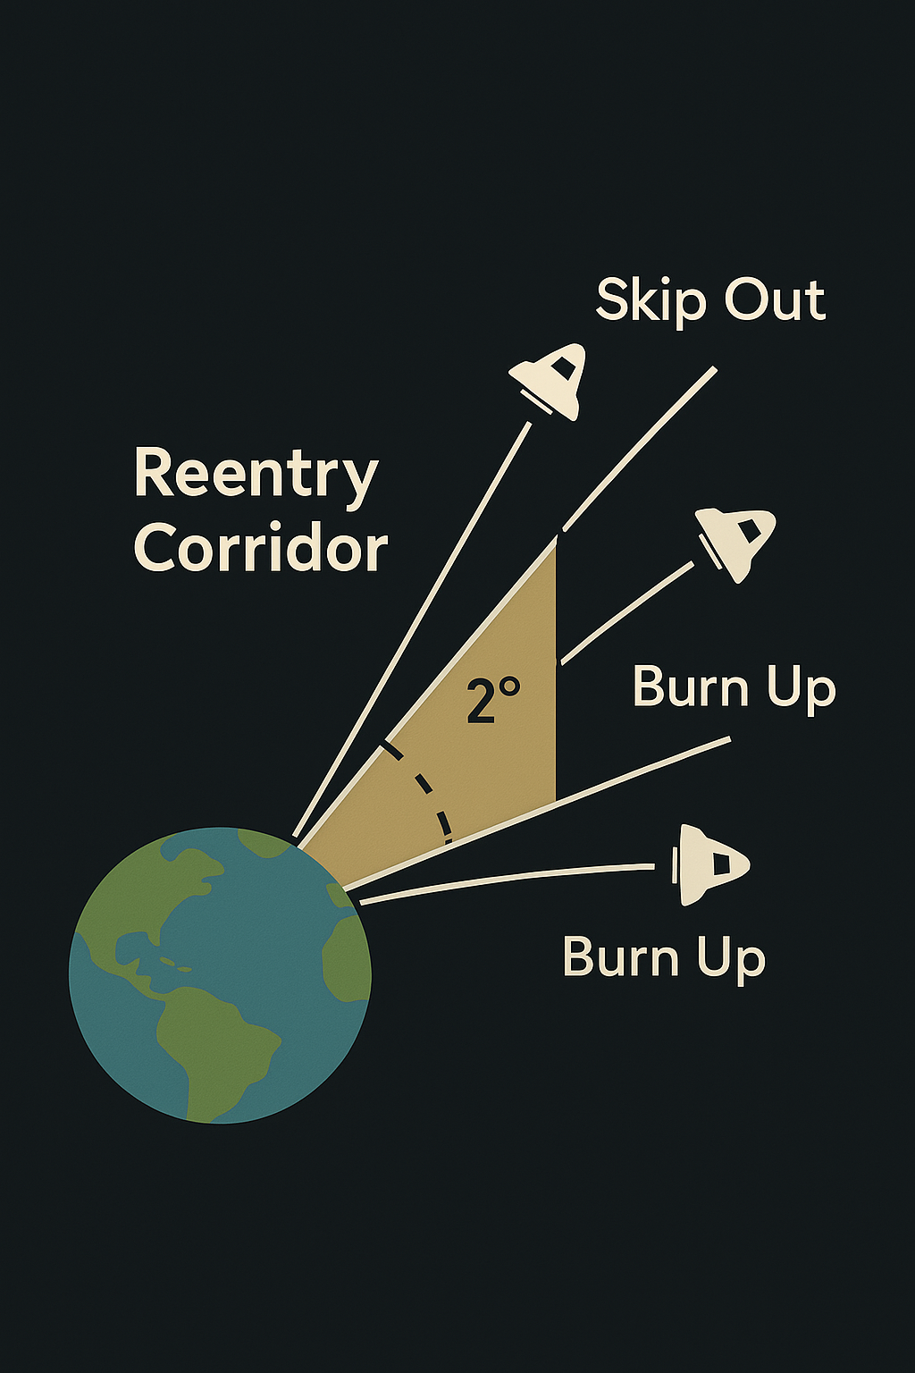

## THE FINAL CHALLENGE

**After 4 Days of Survival:**

**One Last Obstacle:**

* Must hit Earth's atmosphere at EXACT angle
* Window of success: Only ~2° margin
* Too shallow = skip off into space forever
* Too steep = burn up from heat and g-forces
* No second chance

The Stakes: Get it perfect or die on live TV

## THE PHYSICS OF RE-ENTRY

Why Is It So Hard?

**Speed at Entry Interface:**

* Velocity: ~25,000 mph (36,500 feet per second)
* That's 7 miles per second!
* Faster than a speeding bullet (×20)
* Kinetic energy must be dissipated

**Friction with Atmosphere:**

* Spacecraft rams into air molecules
* Air compresses (can't move out of way fast enough)
* Compression creates EXTREME heat
* Heat shield ablates (burns away) to dissipate energy

**The Heat:**

* Peak temperature: ~5,000°F (2,760°C)
* Hot enough to melt steel
* Hot enough to vaporize aluminum
* Heat shield chars and burns away (by design)

**G-Forces:**

* Deceleration from 25,000 mph to 0 mph
* Peak g-force: ~6-7 g's
* Crew weighs 6× normal weight
* Breathing difficult, vision blurred

## THE RE-ENTRY CORRIDOR

**The Narrow Path:**

**Entry Angle Definition:**

* Measured relative to Earth's horizon
* Negative angle = downward path
* Apollo 13 target: ~-6.2° to -6.5°
* Acceptable range: -5.25° to -7.4°

Total Acceptable Window: ~2.15° margin

(That's narrower than a pencil held at arm's length!)

## TOO SHALLOW: SKIP OFF

**If Angle Less Steep Than -5.25°:**

**What Happens:**

1. Spacecraft hits upper atmosphere

2. Not enough air to slow down significantly

3. Spacecraft SKIPS like stone on water

4. Ricochets back into space

5. Insufficient fuel to return

6. Lost in space forever

**The Physics:**

* Lift generated by capsule shape
* Air too thin to capture spacecraft
* Trajectory bends back upward
* Escape velocity maintained
* No way to turn around

**The Outcome:**

☠️ Oxygen runs out in hours

☠️ Crew freezes to death

☠️ Spacecraft becomes tomb in space

☠️ Orbits Earth or Sun forever

☠️ No rescue possible

**Historical Close Call:**

* Gemini 8 (1966) nearly skipped
* Apollo 11 had guidance error (corrected)
* Margin for error is REAL

## TOO STEEP: BURN UP

**If Angle Steeper Than -7.4°:**

**What Happens:**

1. Spacecraft hits atmosphere too steeply

2. Massive air compression instantly

3. Heat shield overheats beyond design

4. G-forces exceed survivable limits

5. Spacecraft breaks apart or burns up

**The Physics:**

* Excessive atmospheric density
* Heat generation exceeds ablation rate
* Thermal protection fails
* Structural stress breaks capsule

**Heat Shield Failure:**

* Designed for specific heat load
* Too steep = heat exceeds capacity
* Shield burns through to cabin
* Interior exposed to plasma

**G-Force Trauma:**

* Peak g's exceed human tolerance
* Blood pooling in lower body
* Loss of consciousness (g-LOC)
* Potential death from g-forces alone

**The Outcome:**

☠️ Heat shield fails

☠️ Cabin burns up (5,000°F plasma)

☠️ Or g-forces kill crew

☠️ Or structural breakup

☠️ Fireball visible from ground

**Historical Tragedy:**

* Soyuz 1 (1967) - parachute failure, impact death
* Soyuz 11 (1971) - cabin depressurization
* Columbia (2003) - heat shield damage, breakup

## THE PERFECT ANGLE

Target: -6.2° to -6.5° (Apollo 13)

**What Happens:**

✅ Controlled entry into atmosphere

✅ Heat within design limits

✅ G-forces survivable (6-7 g's)

✅ Predictable deceleration path

✅ Parachute deployment altitude reached

✅ Safe splashdown in ocean

**The Entry Profile:**

1. Entry Interface (400,000 ft / 120 km)

2. Peak heating (200,000 ft / 60 km)

3. Peak g-force (150,000 ft / 45 km)

4. Communication blackout (plasma)

5. Blackout ends (80,000 ft / 24 km)

6. Drogue chutes (24,000 ft / 7 km)

7. Main chutes (10,000 ft / 3 km)

8. Splashdown (sea level)

## GUIDANCE CONTROL

**How to Hit the Corridor:**

**The Guidance Computer:**

* Apollo Guidance Computer (AGC)
* Calculates trajectory continuously
* Makes thousands of corrections
* Fires small thrusters to adjust angle
* Maintains precise path through corridor

**Reaction Control System (RCS):**

* 12 small thrusters on CM
* Fire in pulses (milliseconds)
* Adjust pitch, yaw, roll
* Computer controls automatically

**Aerodynamic Lift:**

* CM is NOT symmetric (offset center of gravity)
* Generates lift like tiny wing
* Computer uses lift to "steer"
* Can aim for Pacific landing zone

**Manual Backup:**

* Crew can override computer
* Hand controller for thrusters
* But nearly impossible to be accurate enough
* Computer is essential for survival

## THE APOLLO 13 CHALLENGE

**Why Re-entry Was Even Harder:**

**The Frozen Computer:**

* Guidance computer powered down for 4 days
* Temperature: 38°F (not designed for this)
* Condensation and ice on circuits
* NOT designed to shutdown and restart
* Unknown if it would work

**The Risk:**

* If computer fails to restart → manual control
* Manual control → low probability of success
* Exhausted crew after 4 days of hell
* One chance to get it right

The Decision: Risk the computer restart

* Engineers designed careful power-up sequence
* Crew held their breath...
* Computer restarted! ✅
* Systems came online
* Guidance active

**The Execution:**

* Computer controlled re-entry
* Made thousands of micro-adjustments
* Kept spacecraft in corridor perfectly
* Entry angle: -6.2° (PERFECT!)

## COMMUNICATION BLACKOUT

**The Plasma Sheath:**

**During Re-entry:**

* Heat creates ionized plasma around spacecraft
* Plasma blocks radio waves
* All communications CUT OFF
* Ground has no idea if crew is alive

Expected Blackout: 3-4 minutes

Apollo 13 Blackout: 4 minutes 24 seconds

* Longer than normal (deeper entry?)
* Mission Control tense
* Families terrified
* World watching

Then: "Okay, Joe." (Swigert's voice)

* Cheers erupt!
* They survived!
* They're coming home!

## THE PARACHUTES

**Final Phase:**

**Parachute Sequence:**

**1. Drogue Chutes (24,000 ft):**

• Two small chutes deploy

• Stabilize spacecraft

• Slow from 300 mph to 175 mph

**2. Main Chutes (10,000 ft):**

• Three massive orange-and-white chutes

• Each 83 feet diameter

• Slow to 22 mph for splashdown

**The Worry:**

* Will parachutes deploy after 4 days frozen?
* Mechanisms could be frozen
* Pyrotechnic charges might fail

**The Reality:**

* All parachutes deployed perfectly
* Beautiful sight from TV cameras
* Three chutes blooming
* Odyssey descending safely

## SPLASHDOWN ACCURACY

**The Target:**

**Landing Zone:**

* Pacific Ocean
* Near USS Iwo Jima (recovery ship)
* Specific coordinates radioed

**Apollo 13 Splashdown:**

* Distance from ship: 3.5 miles
* Essentially perfect!
* Computer-guided re-entry worked flawlessly
* Despite frozen restart, manual alignment, damaged systems

**The Math:**

* Traveled 240,000+ miles
* Aimed for target size of small island
* Hit within 3.5 miles
* Accuracy: 99.999%

## THE MIRACLE

**What Had to Go Right:**

✅ Free-return trajectory burn (perfect)

✅ PC+2 speed-up burn (perfect)

✅ Manual navigation using Sun/Earth (worked)

✅ Mid-course corrections (on target)

✅ Battery jump-start (successful)

✅ Frozen computer restart (miraculous)

✅ Guidance system operation (flawless)

✅ Re-entry angle (perfect -6.2°)

✅ Heat shield integrity (held together)

✅ Parachute deployment (all three chutes)

✅ Splashdown accuracy (3.5 miles from ship)

Any ONE failure = death

## THE NUMBERS

**Re-entry Statistics:**

Entry Velocity: ~25,000 mph

Peak Heat: ~5,000°F

Peak G-Force: 6-7 g's

Blackout Duration: 4 min 24 sec

Entry Angle: -6.2° (perfect!)

Acceptable Range: -5.25° to -7.4°

Margin of Error: ±1.15° (less than 2°)

Landing Accuracy: 3.5 miles from target

Crew Survival: 100% ✅

## DID YOU KNOW?

**Re-entry Facts:**

* Heat shield ablates (burns) ~1 inch during re-entry
* Charred material carries away heat
* This is BY DESIGN (not a failure)
* Peak g-forces compress crew into couches
* Lovell: "It felt like someone sitting on my chest"
* Training in centrifuge prepared them
* Plasma blackout creates "ion sheath"
* Radio waves can't penetrate
* Like trying to talk through fire
* Apollo 13's re-entry was nominal (perfect)
* Despite everything that went wrong before
* The computer saved their lives

## THE LESSON

Physics doesn't care about your problems.

Hit the corridor or die.

**The numbers don't lie:**

* Too shallow: Skip off and float forever
* Too steep: Burn up in fireball
* Just right: Live

Precision matters.

Computers save lives.

Math works.

And three men came through fire

To land safely in the ocean.

📐 2° Window

**🔥 5,000°F**

🎯 Perfect Angle

✅ Survived

**THEY THREADED THE NEEDLE.**

NARRATIVE SLIDE #6

# RE-ENTRY & SPLASHDOWN

*April 17, 1970 | "Hello, Houston, this is Odyssey. It's good to see you again."*

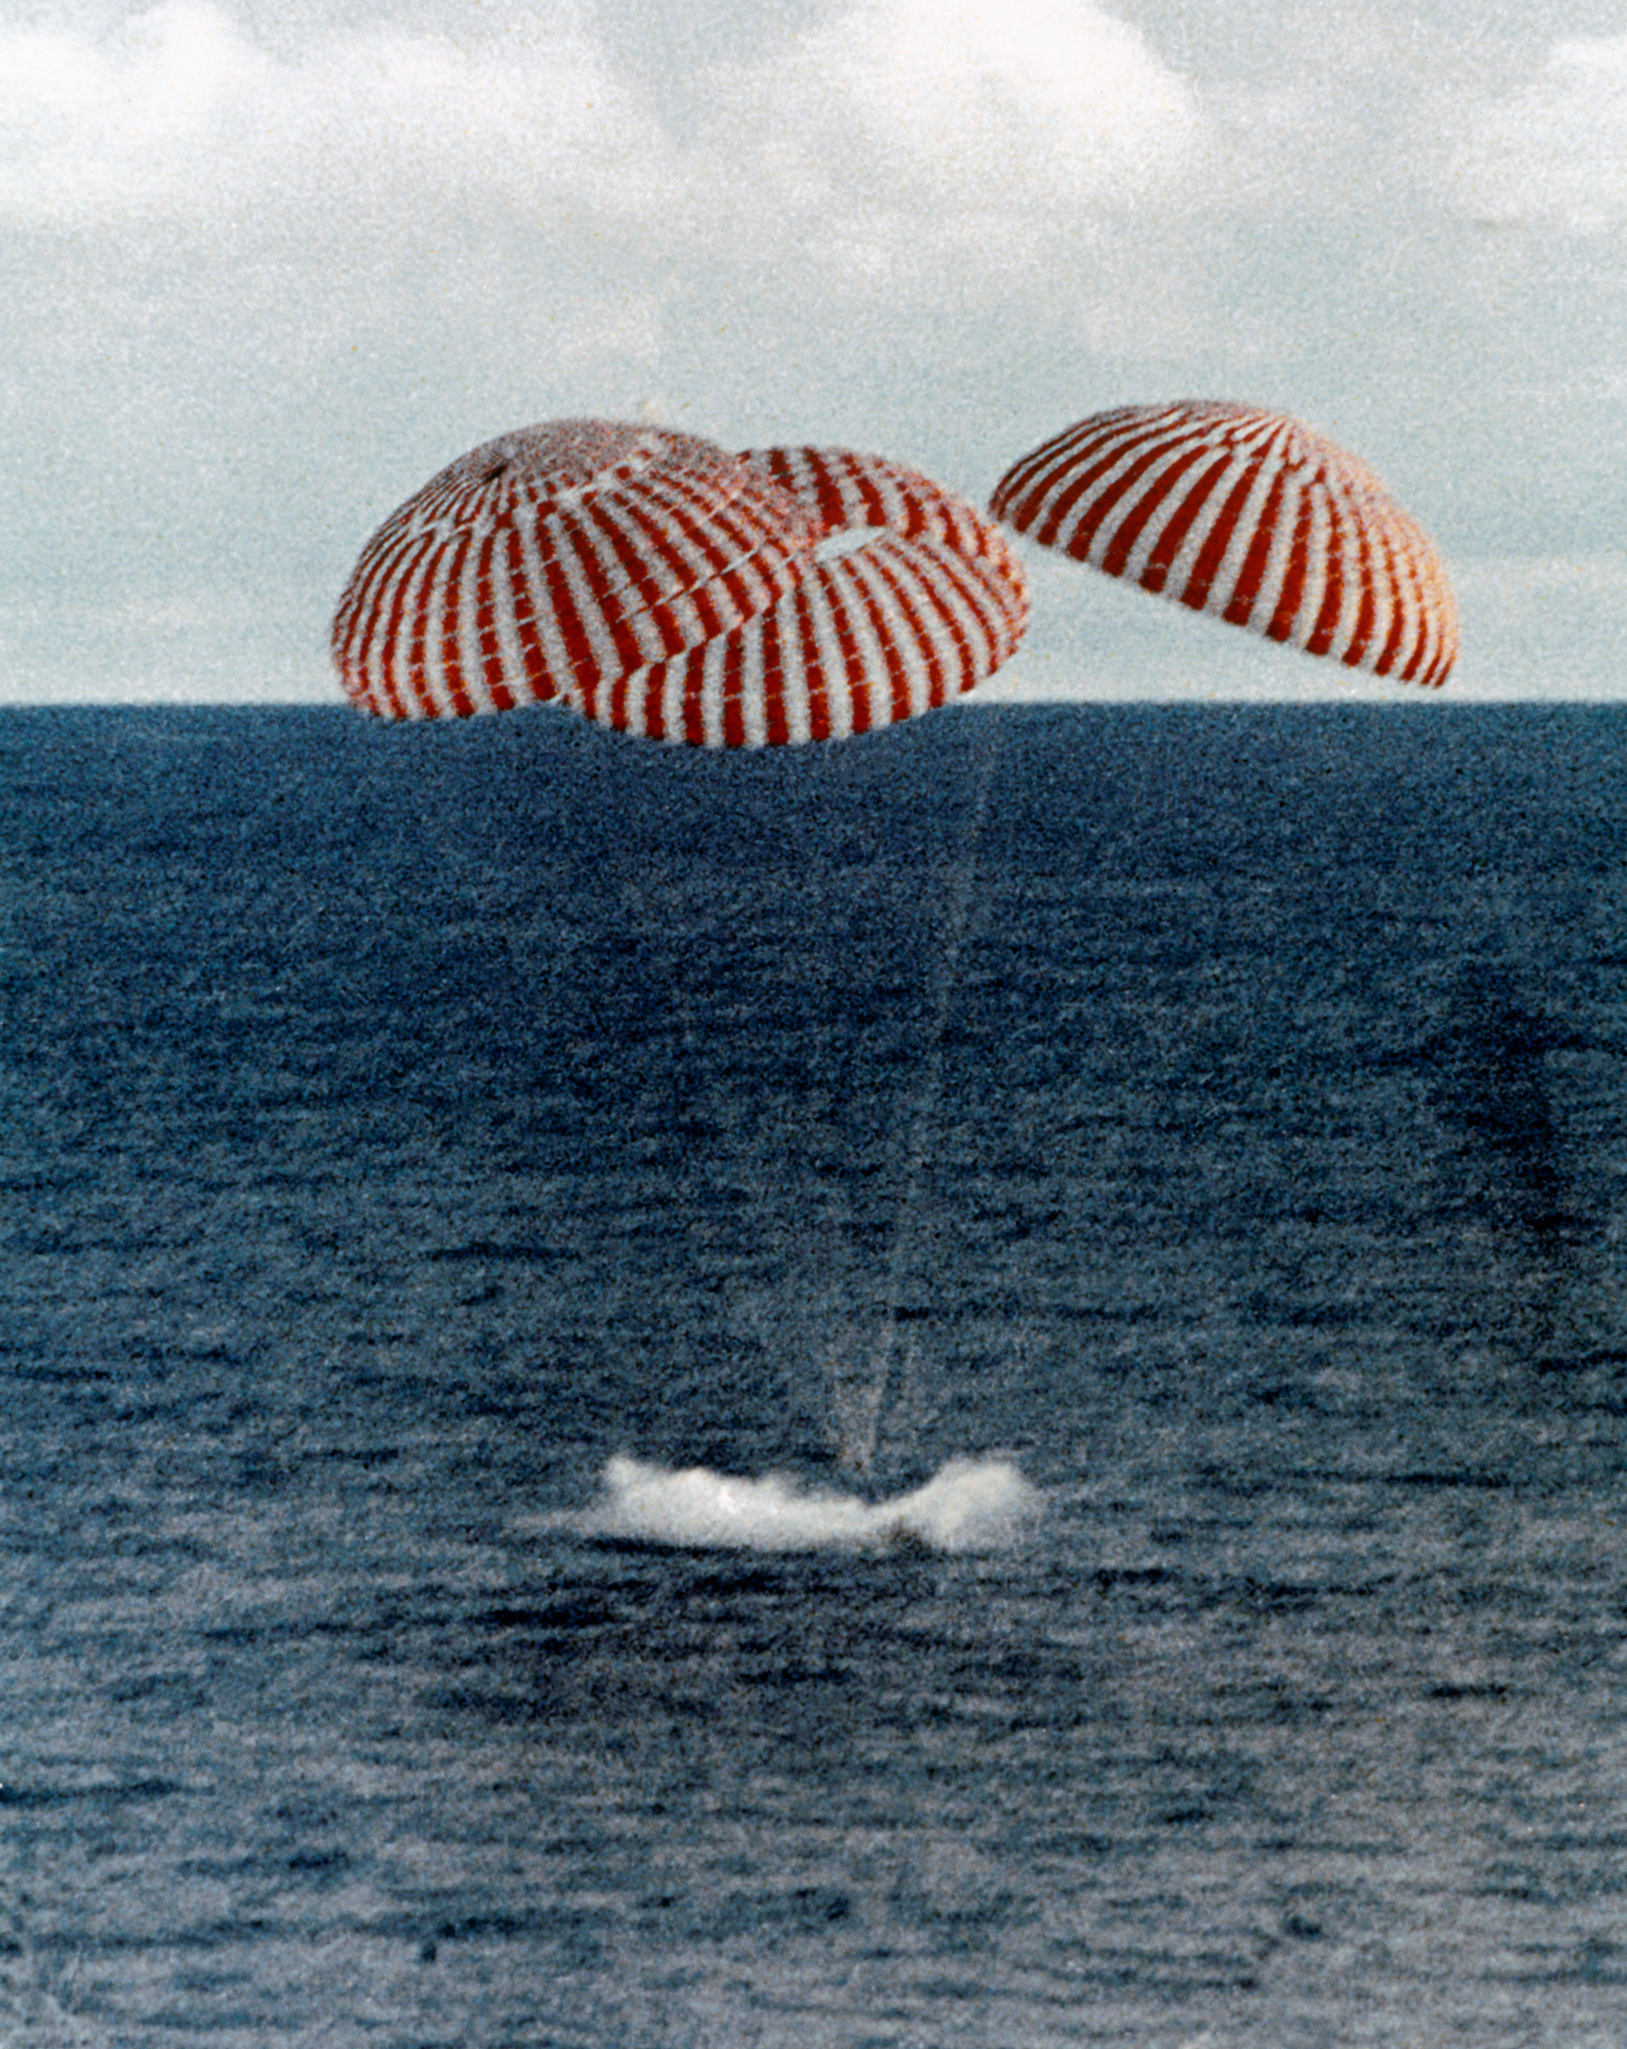

## THE FINAL CHALLENGE

GET 142:40:46 - Entry Interface (400,000 ft altitude)

Time: 11:53 AM Houston time

Location: Approaching Earth's atmosphere

Status: All or nothing

## THE RE-ENTRY CORRIDOR

**The Physics of Survival:**

Target Angle: ~-6.5° (Apollo 13 aimed for ~-6.2°)

Acceptable Window: -5.25° to -7.4° (only ~2.1° margin!)

**Too Shallow (less than -5.25°):**

* Spacecraft SKIPS off atmosphere like stone on water
* Flung back into space
* No way to return
* Crew lost forever

**Too Steep (more than -7.4°):**

* Spacecraft BURNS UP from friction
* G-forces crush crew
* Heat shield fails
* Death on live television

**The Guidance Computer:**

* Frozen for 4 days at 38°F
* Restarted against design specifications
* Now controlling life-or-death trajectory
* Making thousands of calculations per second
* Adjusting angle with precision

## COMMUNICATION BLACKOUT

GET 142:40:46 - Entry Interface

**Re-entry Begins:**

* Spacecraft hits atmosphere
* Friction creates plasma sheath
* Radio waves can't penetrate plasma
* All communications CUT OFF

Expected Blackout Duration: 3-4 minutes

**The World Waits:**

* Mission Control silent
* Families praying
* Media holding breath
* Recovery ships scanning horizon
* No word from crew

Seconds tick by...

1 minute... 2 minutes... 3 minutes...

Normal blackout should end at 3 minutes...

3 minutes 30 seconds...

Still no signal.

4 minutes...

Still silence.

Mission Control tense—something wrong?

## 4 MINUTES 24 SECONDS

Longer than any previous Apollo mission...

Then...

**Jack Swigert's Voice:**

"Okay, Joe."

**CapCom Joe Kerwin:**

"Okay, we read you, Jack!"

CHEERS erupt in Mission Control!

They're alive!

They survived re-entry!

## PARACHUTE DEPLOYMENT

GET 142:48 - Parachute Sequence

**Sequence of Events:**

1. Drogue chutes deploy (24,000 ft)

• Stabilize spacecraft

• Slow initial descent

2. Main chutes deploy (10,000 ft)

• Three massive orange-and-white parachutes

• Each 83 feet in diameter

• Slow descent to safe splashdown speed

**TV Cameras Capture:**

* Three beautiful chutes blooming
* Odyssey dangling beneath
* Descending toward Pacific Ocean
* Global audience watches in real-time

## SPLASHDOWN

Time: 12:07:44 PM Central Time

Date: April 17, 1970

Location: Pacific Ocean

Coordinates: 21°38'24"S, 165°21'42"W

Distance from USS Iwo Jima: 3.5 miles (perfect!)

**The Impact:**

* Odyssey hits water
* Capsule bobs upright
* Flotation bags deploy
* All three crew members SAFE

**USS Iwo Jima Recovery:**

* Helicopters dispatched immediately
* Navy divers jump to attach flotation collar
* Crew hatch opens
* Fresh air!

## THE CREW EMERGES

**Recovery Sequence:**

**Fred Haise (first out):**

* Kidney infection, fever
* Dehydrated, weak
* But walking

**Jim Lovell (second):**

* Exhausted but smiling
* Waving to cameras
* Relief visible

**Jack Swigert (last):**

* Dehydrated, tired
* Grateful to be alive
* Still can't believe they made it

**Medical Assessment:**

* Weight loss: 31.5 pounds combined

- Lovell: 14 lbs

- Haise: 6 lbs (kidney infection limited appetite)

- Swigert: 5 lbs

* Severe dehydration (all crew)
* Hypothermia (all crew)
* Fred Haise: Kidney infection with fever (103°F)
* Minor injuries and frostbite
* BUT ALIVE

## MISSION STATISTICS

Total Mission Duration: 5 days, 22 hours, 54 minutes

Distance Traveled: ~622,000 miles total

Closest Approach to Moon: ~158 miles (254 km)

Peak Velocity: ~25,000 mph

Temperature in LM: 38°F minimum

Water Ration: 6 oz/day per person

Weight Loss: 31.5 lbs combined

Survival: 100% ✅

## THE WORLD CELEBRATES

**Global Reaction:**

* Churches ring bells in celebration
* President Nixon calls crew aboard Iwo Jima
* Ticker tape parades planned
* "Successful failure" becomes iconic phrase

**Mission Control:**

* Gene Kranz: "I wasn't about to lose those guys."
* Controllers exhausted but triumphant
* Problem-solving under pressure saved lives
* Every simulation, every backup plan paid off

**The Message:**

* Teamwork saved three lives
* Ingenuity overcame impossible odds
* Calm problem-solving under pressure
* Never give up

## GENE KRANZ'S WORDS

"Failure is not an option."

Though he never said exactly those words during Apollo 13, the spirit was real:

* Work the problem
* Stay calm
* Don't make it worse by guessing
* Trust your team
* Never give up

## THE FINAL WORDS

**Jim Lovell (after splashdown):**

"We just put Sir Isaac Newton in the driver's seat."

Translation: The physics worked. The math worked. The people worked.

And three men came home alive.

## LESSONS LEARNED

**From the Explosion:**

* Redesign oxygen tanks (new safety features)
* Add third oxygen tank for redundancy
* Improve wiring insulation
* Better testing procedures

**From the Rescue:**

* LM as lifeboat validated
* Backup procedures now standard
* Emergency checklists expanded
* Training for improbable scenarios

**From the Crew:**

* Teamwork under pressure
* Trust the people on the ground
* Stay calm, work the problem
* Improvise when necessary
* Never give up hope

Apollo 13: The most successful failure in NASA history.

🌎 → 🚀 → 🌕 → 🏠

**MISSION COMPLETE**

INFO SLIDE #8

# LESSONS LEARNED

*How Apollo 13 Made Spaceflight Safer*

## THE PARADOX

Apollo 13: NASA's "Successful Failure"

**Failed Mission:**

❌ Never landed on Moon

❌ Never walked on Fra Mauro

❌ Never collected lunar samples

❌ Never deployed experiments

**Successful Rescue:**

✅ All three crew members survived

✅ Every system performed when needed

✅ Every decision was correct

✅ Teamwork saved lives

✅ Innovation under pressure

The Result: Valuable lessons learned without loss of life

## TECHNICAL LESSONS

**Spacecraft Redesign Changes:**

**OXYGEN SYSTEM OVERHAUL:**

**Before Apollo 13:**

* Two oxygen tanks in Service Module
* 28V thermostatic switches on 65V circuit
* Vulnerable to overheating
* Single-point failure possible

**After Apollo 13:**

✅ THREE oxygen tanks (redundancy)

✅ Proper voltage-rated switches

✅ Improved insulation and wiring

✅ Better thermostatic controls

✅ Relocated third tank to different sector

✅ Temperature monitoring during ground tests

✅ X-ray inspection of tank interiors

**POWER SYSTEM IMPROVEMENTS:**

✅ Additional battery capacity in CM

✅ Emergency power transfer procedures documented

✅ LM-to-CM battery jump-start procedure added

✅ Backup power routing designed

**LIFE SUPPORT REDUNDANCY:**

✅ More water storage capacity

✅ Additional CO2 scrubber canisters

✅ Universal scrubber adapter designed

✅ Emergency procedures for LM as lifeboat

**STRUCTURAL CHANGES:**

✅ Service Module panel reinforcement

✅ Better isolation between sectors

✅ Explosion containment improvements

✅ Stronger wiring harness protection

## OPERATIONAL LESSONS

**Procedures That Changed:**

**INSPECTION AND TESTING:**

Before: Limited inspection of sealed components

**After:**

✅ X-ray all pressure vessels

✅ Document all anomalies (no matter how small)

✅ Temperature monitoring during tests

✅ Investigation of ANY unusual readings

✅ More thorough pre-flight reviews

The Lesson: Small issues can become catastrophic

**EMERGENCY PROCEDURES:**

Before: Limited backup plans

**After:**

✅ LM validated as lifeboat (procedures documented)

✅ Mailbox adapter instructions in manual

✅ Battery jump-start procedure added

✅ Manual navigation backup procedures

✅ Power-down/restart sequences documented

✅ Communication discipline protocols

The Lesson: Plan for improbable scenarios

**CREW TRAINING:**

✅ More emergency scenario simulations

✅ Practice with limited resources

✅ Improvisation training

✅ Stress management techniques

✅ Sleep deprivation exercises

✅ Cold environment training

The Lesson: Train for the worst-case scenario

## TEAMWORK LESSONS

**Human Factors That Saved Lives:**

**GROUND-CREW COORDINATION:**

**What Worked:**

✅ Clear communication (no jargon confusion)

✅ Trust between Earth and space

✅ Engineers worked around the clock

✅ Real-time problem-solving collaboration

✅ Crew followed instructions precisely

**Gene Kranz's Leadership:**

* "Work the problem, people"
* "Don't make it worse by guessing"
* "Let's not make the problem bigger"
* Calm, methodical approach
* Empowered teams to find solutions

The Lesson: Clear communication and trust save lives

**CREW DYNAMICS:**

**What Made It Work:**

✅ No blame game (Swigert flipped switch, no fault)

✅ Each member focused on their expertise

✅ Lovell's experience provided calm leadership

✅ Rookies performed under pressure

✅ Team supported each other through stress

The Lesson: Focus on solutions, not blame

**MISSION CONTROL CULTURE:**

Before: "Go fever" - pressure to launch

**After:**

✅ Safety prioritized over schedule

✅ Encouraged to speak up about concerns

✅ "Failure is not an option" mentality

✅ Empower engineers to stop missions

The Lesson: Listen to engineers, not just managers

## ENGINEERING LESSONS

**Problem-Solving Principles:**

**WORK WITH WHAT YOU HAVE:**

**The Mailbox:**

* No special tools available
* Used duct tape, cardboard, plastic bags
* Designed solution in hours
* Built by crew in ~1 hour
* Worked perfectly

The Lesson: Ingenuity beats fancy equipment

**REDUNDANCY SAVES LIVES:**

**Multiple Backups:**

✅ LM systems independent of CM/SM

✅ Multiple oxygen sources

✅ Backup navigation methods

✅ Alternative communication systems

✅ Manual overrides for computers

The Lesson: Never rely on single systems

**TEST, TEST, TEST:**

**Ground Simulation:**

* Engineers built mailbox prototype on Earth
* Tested battery jump-start procedure
* Simulated power-up sequences
* Verified before radioing to crew

The Lesson: Test before you commit

**SIMPLE SOLUTIONS OFTEN BEST:**

**Examples:**

* Duct tape sealed mailbox (not fancy adhesive)
* Sun/Earth for navigation (not complex star charts)
* Manual alignment (not waiting for debris to clear)
* Water rationing (not complex purification)

The Lesson: Don't overcomplicate under stress

## MISSION PLANNING LESSONS

**"What If" Scenarios:**

**EXPECT THE UNEXPECTED:**

**What If Questions Added:**

* What if oxygen tank explodes?
* What if LM becomes lifeboat?
* What if guidance computer fails?
* What if we can't use stars for navigation?
* What if main engine is damaged?

Each "What If" got a procedure.

**CONTINGENCY PLANNING:**

✅ Abort scenarios at every phase

✅ Alternative trajectories documented

✅ Resource calculations for emergencies

✅ Rescue options pre-planned

The Lesson: Hope for the best, plan for the worst

**CONSUMABLES MARGINS:**

Before: Tight margins (just enough)

**After:**

✅ Larger safety margins on oxygen

✅ More water storage

✅ Extra batteries

✅ Additional CO2 scrubbers

The Lesson: Margin saves lives

## CULTURAL LESSONS

**The "Successful Failure" Mindset:**

**REDEFINING SUCCESS:**

Old Definition: Complete mission objectives

New Definition: Bring crew home safe

**Eugene Cernan (Apollo 17):**

"We learned that success isn't landing on the Moon. Success is getting everyone home alive."

**EMBRACING FAILURE AS LEARNING:**

**NASA's Response:**

* Didn't hide mistakes
* Published full investigation report
* Shared lessons with world
* Used failure to improve

The Lesson: Honest assessment prevents future tragedy

**PUBLIC PERCEPTION:**

**Media Response:**

* Apollo 13 crew became heroes
* Not for landing on Moon
* For survival and problem-solving
* Public rallied behind rescue

The Lesson: How you handle failure matters

## HISTORICAL IMPACT

How Apollo 13 Changed Space Exploration:

**IMMEDIATE CHANGES (Apollo 14-17):**

✅ All remaining Moon missions redesigned systems

✅ Third oxygen tank added

✅ Improved procedures

✅ Additional training

✅ All missions successful!

**LONG-TERM IMPACT:**

**Space Shuttle Program:**

* Redundancy designed from start
* Abort scenarios for every phase
* Crew escape systems
* (Lessons forgotten in Challenger/Columbia tragedies)

**International Space Station:**

* Multiple life support systems
* Escape vehicles (Soyuz) always docked
* Redundant power and oxygen
* Emergency procedures extensive

**Future Missions (Artemis, Mars):**

* Apollo 13 lessons still studied
* Redundancy principles applied
* Contingency planning essential
* Crew safety paramount

## HUMAN LESSONS

**What Apollo 13 Taught the World:**

**STAY CALM UNDER PRESSURE:**

* Panic kills, calm problem-solving saves
* "Work the problem"
* Focus on what you can control
* One step at a time

**TRUST YOUR TEAM:**

* Crew trusted Mission Control
* Mission Control trusted crew
* Engineers trusted each other
* Teamwork = survival

**NEVER GIVE UP:**

* Situation seemed hopeless
* 200,000 miles from home
* Crippled spacecraft
* Yet they found a way

**IMPROVISE AND ADAPT:**

* When perfect fails, improvise
* Use what you have
* Think creatively
* Simple solutions work

## THE FINAL LESSON

**What Made Apollo 13 a Success:**

**NOT the Technology:**

* Computer froze but restarted
* Duct tape, not advanced materials
* Manual navigation, not automation

**NOT Perfect Planning:**

* Explosion was unexpected
* Procedures written in real-time
* Many improvisations required

**BUT the People:**

✅ Engineers who solved impossible problems

✅ Crew who stayed calm under stress

✅ Flight directors who made tough calls

✅ Families who kept faith

✅ Public who rallied in support

Gene Kranz: "Failure is not an option."

But he didn't mean never fail.

He meant never stop trying.

## QUOTES TO REMEMBER

**Words of Wisdom:**

**Gene Kranz:**

"When bad things happened, we just calmly laid out all the options, and failure was not one of them."

**Jim Lovell:**

"Houston, we've had a problem."

(Calm, factual, no panic)

**Ken Mattingly (pulled from flight):**

"I was asked why I didn't resent being pulled from the mission. I told them because the malfunction would have happened whether I was there or not, and they needed my help on the ground."

**Jack Swigert (after splashdown):**

"I'm grateful to be here."

**Fred Haise:**

"We didn't go to the Moon, but we went somewhere no one expected."

## THE LEGACY

**Apollo 13's Gift to Humanity:**

**🧠 Engineering Excellence:**

Redundancy, testing, safety margins

**🤝 Teamwork Under Pressure:**

Communication, trust, collaboration

**🛠️ Creative Problem-Solving:**

Improvisation, using what's available

**💪 Human Resilience:**

Never giving up, enduring hardship

**🌍 Global Unity:**

World watched and hoped together

## DID YOU KNOW?

**Surprising Impacts:**

* Duct tape sales increased after Apollo 13
* "Successful failure" became business school case study
* Gene Kranz's white vest in Smithsonian
* Apollo 13 movie (1995) won Academy Awards
* Business card: "I helped save Apollo 13" given to Boy Scouts who study the mission

**The Mission That Failed:**

* Taught more than any successful mission
* Showed human capability under stress
* Proved teamwork saves lives
* Demonstrated value of preparation

## THE FINAL MESSAGE

What Should We Remember?

**When things go wrong:**

✅ Stay calm

✅ Work the problem

✅ Trust your team

✅ Use what you have

✅ Never give up

**When you succeed:**

✅ Document lessons learned

✅ Share knowledge

✅ Improve for next time

✅ Prepare for failure

**When you fail:**

✅ Learn from it

✅ Make it count

✅ Use it to improve

✅ Help others learn

Apollo 13 didn't land on the Moon.

But it landed in history.

Not as a failure.

As a triumph of the human spirit.

🚀 Mission Failed

👨‍🚀 Crew Survived

📚 Lessons Learned

🌟 Legacy Eternal

"FAILURE IS NOT AN OPTION" — Gene Kranz

But when it happens anyway,

Make it a successful failure.

**MISSION COMPLETE.**

# Apollo 13 Mission Patch

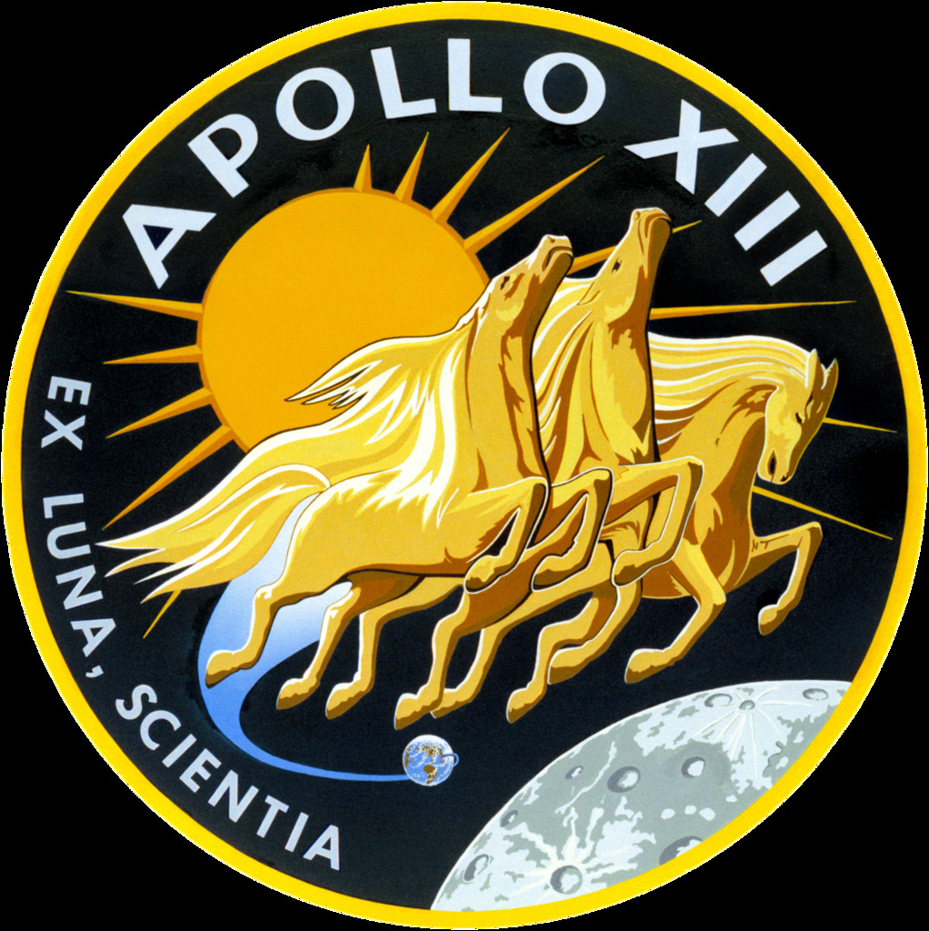

*"Ex Luna, Scientia"*

*From the Moon, Knowledge*